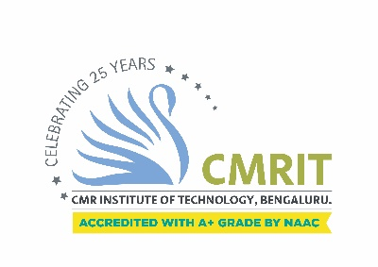

Report of Inauguration of Academic Programmes 2019-20

held at CMR institute of Technology.

**Youth empowerment will reform the county: Justice N Santosh Hegde**

The Inauguration of first year BE programs was held on 03rd August 2019 at 9.30am The Chief guest for the meaningful program was Honorable Justice N Santosh Hegde former lokayuktha Karnataka, The programme commenced with the lamp lighting by the Dignitaries including Dr. Sabitha Ramamurthy Chancellor CMR University, Dr Sanjay Jain Principal CMRIT and Dr.B Narasimha Murthy Vice principal CMRIT, The parents and teachers were briefed regarding the history, growth and milestones, academic infrastructure, curriculum design, placements of CMR Institute of Technology

The Principal of CMRIT, Dr Sanjay Jain welcomed the Chief Guests, parents and students, The chief Guest N Santosh Hegde, touched the heart of the audience by his motivational speech. Country suffers from wide spreading corruption, probably 10 % of budget reaches common man, and He encouraged the students to build a society which boycotts corruption. He advised them to achieve contentment by avoiding greed. He reminded the audience that acquiring humanism is the way to enlightenment. He pointed out that, greed is the reason for all modern day maladies and has chased away the humanity in human beings. Hence creating a greed-free society is the need of the hour. N Santosh Hegde also shared his real life experiences while working as Lokayuktha of Karnataka.

Congratulating over more than 140 achievers in academics, projects, sports , he appreciated innovative projects such as Decentralized Voting app, Neural network for gaming, Metro billing system and others. He released Project management through Panchatantra a novel book on managing targets to achieve success, written by college students.

Dr Sabitha Ramamurthy Chancellor, CMR University who was present on the occasion mentioned that every branch of engineering has potential to provide solutions to real life problems. Learn to manage your life while facing several challenges, she said. She stressed the need life skills for engineers. She observed that excellence can be achieved with talent and right attitude. Budding engineers need to inculcate passion for learning, creative thinking and continuously update knowledge. Stressing the need for large scale Industry- Institution Interaction, he encouraged budding engineers to concentrate on soft skills. She felicitated academic toppers and innovators.

An orientation programme was held to enlighten students and parents about the course structure, examination details and most importantly their responsibilities. Principal Dr Sanjay Jain interacted with parents and students on current scenario in the industry, challenges and placement opportunities. He stressed that students must take up research and elaborated on the research facilities provided in the college. Many parents and students who were present felt happy over learning about their responsibilities and future prospects. First year student Aditya vaibhav who is interested in pursuing higher education said that ‘this interaction has given me lot of useful information’. Ms Harshita, a student of Electronics and communications engineering mentioned that she is excited to see lot of job opportunities in this field.