** Department of Civil Engineering**

**Sem VI Sub code: 15CV653**

**ALTERNATIVE BUILDING MATERIALS**

**VTU June/ JULY 2018 – Prepared by N. Soundarya (Asst. Prof.) 02/07/2018**

**Module – 1**

1. **a. Explain the concept of energy embodied in building materials. (8Marks)**

Construction activities of all types involve expenditure of energy in one for (or) other. ¬ In traditional construction, the source of energy was either animate energy which used the muscle power of human being and animals (or) bio mass energy which are used as a source of thermal energy. After the advent of industrial revolution, human society is increasingly dependent on fossil fuel for energy Modern construction employs significant amounts of energy whether it is thermal energy (or) energy for transport It is useful to recognize different categories of energy consumption in a building, and this may be listed as a. Embodied energy in building materials b. Energy consumption during building construction c. Energy utilized for maintenance during the life span of building d. Energy spent in demolition of building at the end of its life. The four categories of energies listed above constitute the life cycle energy cost of a building. ¬ The primary use of energy in building materials is in the production of building material. Bricks and tiles are produced by burning coal (or) fire wood in kilns. Cement and lime are again produced by heating clay and lime stone using coal and steel is also produced by using coking coal as the fuel. ¬ Energy in bricks is usually calculated by determining the amount of firewood (or) coal used for brick burning. In south India, one brick needs 0.25 to 0.30 kg of wood for energy. Assuming an energy value of wood of 15 MJ per kg, we get energy content in the range of 3.75 – 4.45 MJ.

1. **b. Explain thin global warming (8Marks)**

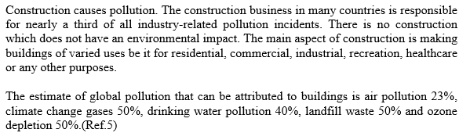

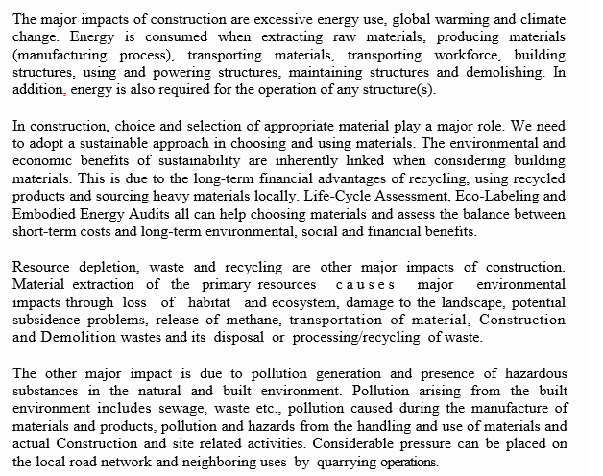

1. **a List out the various environmental friendly and cost effective building technologies. Explain any one in brief. (8Marks)**

**Construction Technique adopted:**

**(i) Foundation, (ii) Wall, (iii) Roof and (iv) lintel.**

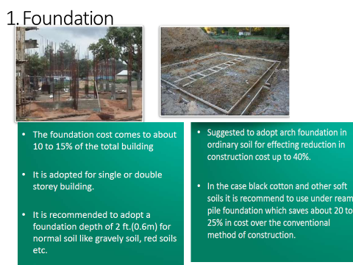

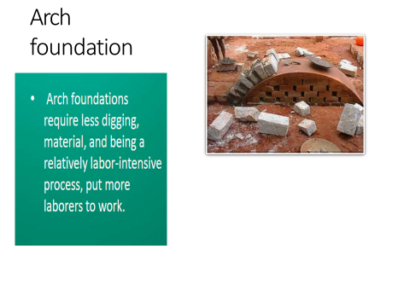

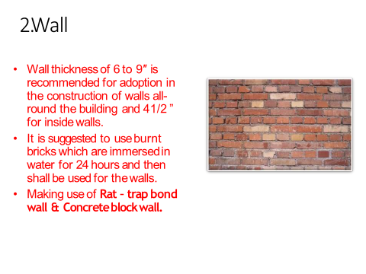

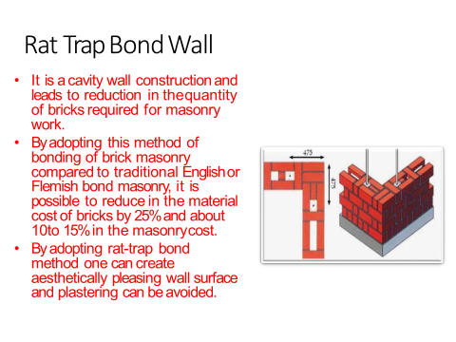

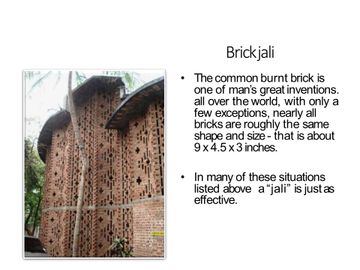

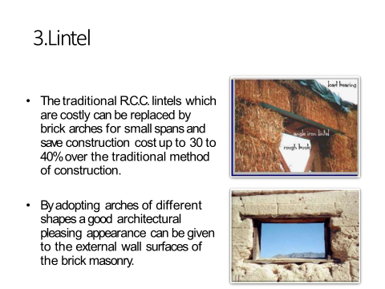

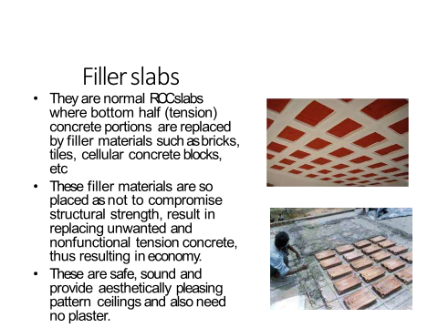

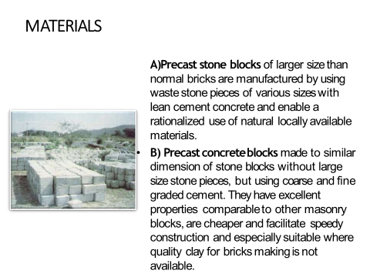

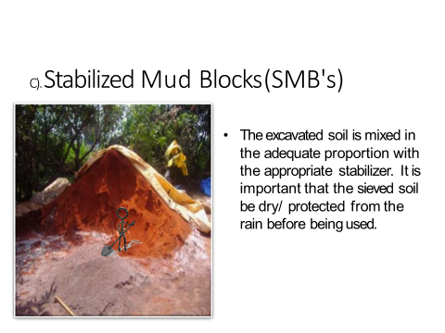

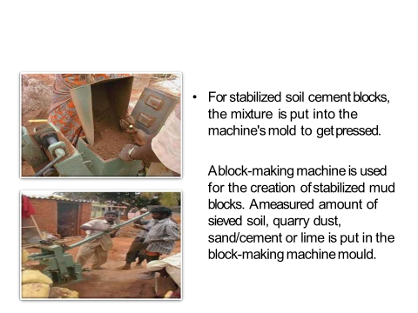

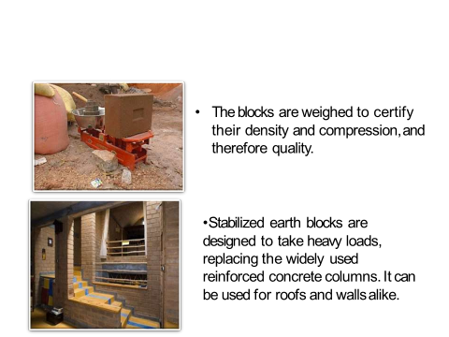

**2. b. What are the advantages of LEED? List out the five main credit categories in LEED rating system. (8Marks)**

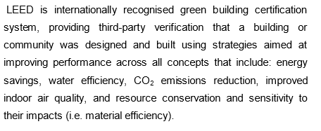

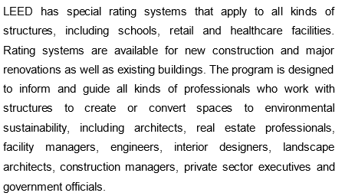

**Key Concepts in LEED Certification are:**

i) Sustainable building sites

ii) Water Efficiency

iii) Energy efficiency/ Atmospheric impact

iv) Sustainable materials selection

v) Indoor environmental quality

vi) Innovation and design.

**Module – 2**

**3. a. Write a note on: (i) Fal – G Bricks and (ii) Laterite Blocks. (8Marks)**

**(i) Fal – G Blocks:**

FAL –G is a ground blend of fly ash, lime, gypsum in suitable proportions which up on hydration, yields strengths in the range of 6-40 MPa, rendering a highly waters imperious hard matrix, with the formation of mineralogical phases during hydration similar to those of ordinary Portland cement (OPC). The proportions of lime and gypsum are dependent upon the chemical constituents and the behavior of fly ash. Theses bricks offer a variable energy efficient and environmental friendly alternative, Fal-G technology can be used in plants with an annual bricks production capacity of 3 million bricks to 30 million bricks. Fal-G bricks completely eliminates the burning of fossil fuels and hence contribution to the reduction of green house gases.

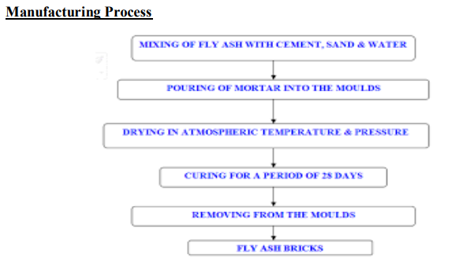

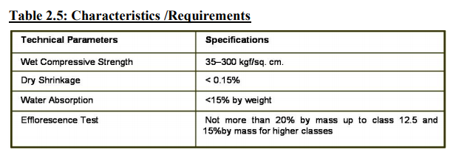

**Advantages:**

• Same number of bricks will cover more area than clay bricks • High Fire Insulation • Due to high strength, practically no breakage during transport and use. • Due to uniform size of bricks mortar required for joints and plaster reduces almost by 50%. • Due to lower water penetration seepage of water through bricks is considerably reduced. • Gypsum plaster can be directly applied on these bricks without a backing coat of lime plaster. • These bricks do not require soaking in water for 24 hours. Sprinkling of water before use is enough.

**(ii) Laterite Blocks:**

The laterite blocks are obtained from laterite or lateritic soil. The process of laterization in soil occurs in the region where the atmospheric temperature varies with very high annual rainfall during high temperature.

Process of laterization: During heavy rainfall silica particles illuviates in to lower layers leaving only iron and aluminum in the upper layer and this upper layer gives honey comb structure i.e., porous nature. The pore is the space where they removed silicon particles existed. This degree of laterization is estimated by calculating the ratio of silicon to sesqui–oxides i.e., Si / (Fe2O3 + Al2O3) Laterite can be treated as a “Weak Rock” for building purpose and when moist it can be easily cut in to regular size blocks. However after exposure to atmosphere lateric blocks shows a hardening behavior which is thought be due to the content and dehydration of iron oxides and arrangement of components.

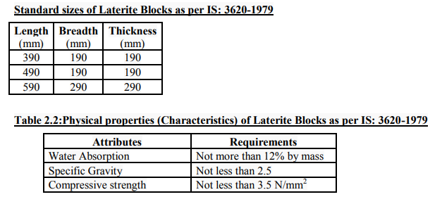

1. **b. List the properties of good mortar.**

**PROPERTIES OF GOOD MORTAR**

1. It should be capable of developing good adhesion with the building units such as bricks, stones etc.
2. It should be capable of developing the designed stresses.
3. It should be capable of resisting penetration of rain water.
4. It should be cheap.
5. It should be durable
6. It should be easily workable
7. It should not affect the durability of materials with which it comes into contact.
8. It should set quickly so that speed in construction may be achieved.
9. The joints formed by mortar should not develop cracks and they should be able to maintain their appearance for a sufficiently long period.

**4. a. Explain the method of manufacturing SMB.**

**The manufacturing process of SMB involves following steps:**

a. Sieve the soil in a 4mm sieve to remove stones and limps of clay

b. Mix sand (or) quarry dust to correct the clay sand percentages in the soil

c. Add cement (or) cement and lime in the appropriation proportion and mix them thoroughly in the dry condition.

d. Sprinkle moisture on to the mixture and further mix thoroughly till the mixture is homogeneous

e. Test for optimum moisture by trying to make a ball of soil in the hand. If a ball can be made without the soil sticking to the hand the moisture content is right

f. Weight the correct amount of moist soil such that a fresh block density of 2.05 gm/cc can be achieved. The weight depends on the volume of the finished block density of 2.05 gm/cc may not be feasible density like 2.0 gm/cc (or) 1.95 gm/cc may be attempted

g. The weighed soil is now poured in to a soil compaction press.

h. The block is now pressed by operating the toggle after closing the lid. The lid may then be opened and to block ejected by again using the lever.

i. The ejected block is then stacked in a five (or) six block high stack for curing

j. Sprinkling of moisture may be pursued up to 21 days to complete the block making process.

**5. a. Write the properties and uses of lime pozzolana cement. (8Marks)**

**Fat lime**

➢ This lime is also known as High Calcium lime, Pure lime, Rich lime or White lime.

➢ It is popularly known as Fat lime.

➢ It slakes vigorously & its volume increases about 2 to 2 ½ times the volume of quick lime.

➢ It is prepared by calcining pure lime composed of 95% of calcium oxide.

➢ Impurities in such limestone are less than 5%.

**Properties**

➢ Hardens very slowly

➢ High degree of plasticity

➢ Soluble in water

➢ Colour is perfectly white

➢ Sets slowly in presence of air, and

➢ Slakes vigorously.

**Uses**

➢ White washing & plastering walls

➢ With sand, it forms lime mortar which is used for brickwork & stonework.

➢ With surkhi, it forms lime mortar used for thick masonry walls, foundations, etc.

➢ (surkhi: powder obtained by grinding of burnt brick).

**Hydraulic lime**

➢ This lime is also known as ‘Water lime’ as it sets under water.

➢ It contains clay & some amount of ferrous oxide & depending upon the percentage of clay,

hydraulic lime is divided as;

o Feebly hydraulic lime

o Moderately hydraulic lime

o Eminently hydraulic lime

**Properties**

➢ Increase in percentage of clay makes slaking difficult & increases the hydraulic property.

➢ With 30% of clay, hydraulic lime resembles natural cement.

➢ Can set underwater & in thick walls with no free circulation of air.

➢ Colour is not perfect white.

➢ Forms a thin paste with water & does not dissolve in it.

**Uses**

➢ Used for plaster works

➢ Hydraulic lime is ground to a fine powder & then mixed with sand & kept aside for 1 week.

➢ It is grounded again & then used for plastering work.

**Poor lime**

➢ It is also known as ‘Impure lime’ or ‘Lean lime’.

**Properties**

➢ Contains more than 30% of clay & slakes very slowly.

➢ Forms a thin paste with water but does not dissolve in it.

➢ Sets or hardens very slowly & has poor binding properties.

➢ Colour is muddy white.

**Uses**

➢ It makes a very poor mortar, that can be used for inferior type of work or places where good

lime is not available.

**Module – 3**

**5. b. List out the different methods employed in manufacturing of FRP and explain any one in brief.**

#### Bladder moulding

Individual sheets of prepreg material are laid up and placed in a female-style mould along with a balloon-like bladder. The mould is closed and placed in a heated press. Finally, the bladder is pressurized forcing the layers of material against the mould walls.

#### Compression moulding

When the raw material (plastic block,rubber block, plastic sheet, or granules) contains reinforcing fibres, a compression molded part qualifies as a fibre-reinforced plastic. More typically the plastic preform used in compression molding does not contain reinforcing fibres. In compression molding, a "preform" or "charge", of [SMC](https://en.wikipedia.org/wiki/Sheet_moulding_compound), BMC is placed into mould cavity. The mould is closed and the material is formed & cured inside by pressure and heat. Compression moulding offers excellent detailing for geometric shapes ranging from pattern and relief detailing to complex curves and creative forms, to [precision engineering](https://en.wikipedia.org/wiki/Precision_engineering) all within a maximum curing time of 20 minutes.

#### Autoclave and vacuum bag

Individual sheets of prepreg material are laid-up and placed in an open mold. The material is covered with release film, bleeder/breather material and a [vacuum bag](https://en.wikipedia.org/wiki/Composite_material#Vacuum_bag_moulding). A vacuum is pulled on part and the entire mould is placed into an autoclave (heated pressure vessel). The part is cured with a continuous vacuum to extract entrapped gasses from laminate. This is a very common process in the aerospace industry because it affords precise control over moulding due to a long, slow cure cycle that is anywhere from one to several hours.[[21]](https://en.wikipedia.org/wiki/Fibre-reinforced_plastic#cite_note-21)This precise control creates the exact laminate geometric forms needed to ensure strength and safety in the aerospace industry, but it is also slow and labour-intensive, meaning costs often confine it to the aerospace industry.

#### Mandrel wrapping

Sheets of prepreg material are wrapped around a steel or aluminium mandrel. The prepreg material is compacted by nylon or polypropylene cello tape. Parts are typically batch cured by vacuum bagging and hanging in an oven. After cure, the cello and mandrel are removed leaving a hollow carbon tube. This process creates strong and robust hollow carbon tubes.

#### Wet layup

Wet layup forming combines fibre reinforcement and the matrix as they are placed on the forming tool. Reinforcing Fibre layers are placed in an open mould and then saturated with a wet [resin](https://en.wikipedia.org/wiki/Resin) by pouring it over the fabric and working it into the fabric. The mould is then left so that the resin will cure, usually at room temperature, though heat is sometimes used to ensure a proper cure. Sometimes a vacuum bag is used to compress a wet layup. Glass fibres are most commonly used for this process, the results are widely known as [fibreglass](https://en.wikipedia.org/wiki/Fibreglass" \o "Fibreglass), and is used to make common products like skis, canoes, kayaks and surf boards.

#### Chopper gun

Continuous strands of fibreglass are pushed through a hand-held gun that both chops the strands and combines them with a catalysed resin such as polyester. The impregnated chopped glass is shot onto the mould surface in whatever thickness and design the human operator thinks is appropriate. This process is good for large production runs at economical cost, but produces geometric shapes with less strength than other moulding processes and has poor dimensional tolerance.

#### Filament winding

[Machines](https://en.wikipedia.org/wiki/Continuous_filament_winding_machine) pull fibre bundles through a wet bath of resin and wound over a rotating steel mandrel in specific orientations Parts are cured either room temperature or elevated temperatures. Mandrel is extracted, leaving a final geometric shape but can be left in some cases.

#### Pultrusion

Fibre bundles and slit fabrics are pulled through a wet bath of resin and formed into the rough part shape. Saturated material is extruded from a heated closed die curing while being continuously pulled through die. Some of the end products of pultrusion are structural shapes, i.e. I beam, angle, channel and flat sheet. These materials can be used to create all sorts of fibreglass structures such as ladders, platforms, handrail systems tank, pipe and pump supports.

#### Resin transfer molding

Also called **resin infusion**. Fabrics are placed into a mould into which wet resin is then injected. Resin is typically pressurized and forced into a cavity which is under vacuum in [resin transfer molding](https://en.wikipedia.org/wiki/Out_of_autoclave_composite_manufacturing). Resin is entirely pulled into cavity under vacuum in vacuum-assisted resin transfer molding. This moulding process allows precise tolerances and detailed shaping, but can sometimes fail to fully saturate the fabric leading to weak spots in the final shape.

**6. a. List out the different agro and industrial wastes. Explain their use as a building material. (8Marks)**

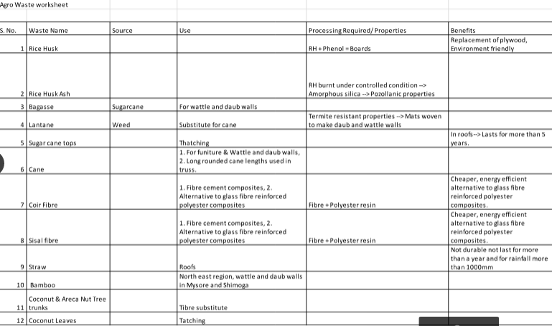

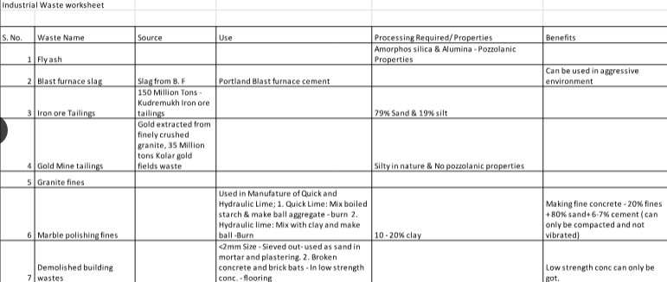

**6. b. Explain the applications of FRP Composites. (8 Marks)**

Fibre-reinforced plastics are best suited for any design program that demands weight savings, precision engineering, finite tolerances, and the simplification of parts in both production and operation. A moulded polymer artefact is cheaper, faster, and easier to manufacture than cast aluminium or steel artefact, and maintains similar and sometimes better tolerances and material strengths.

### Carbon-fibre-reinforced polymers

Rudder of Airbus A310

* Advantages over a traditional rudder made from sheet aluminium are:
  + 25% reduction in weight
  + 95% reduction in components by combining parts and forms into simpler moulded parts.
  + Overall reduction in production and operational costs, economy of parts results in lower production costs and the weight savings create fuel savings that lower the operational costs of flying the aeroplane.

### Glass-fibre-reinforced polymers

Engine intake manifolds are made from glass-fibre-reinforced PA 66.

* Advantages this has over cast aluminium manifolds are:
  + Up to a 60% reduction in weight
  + Improved surface quality and aerodynamics
  + Reduction in components by combining parts and forms into simpler moulded shapes.

Automotive gas and clutch pedals made from glass-fibre-reinforced PA 66 (DWP 12–13)

* Advantages over stamped aluminium are:
  + Pedals can be moulded as single units combining both pedals and mechanical linkages simplifying the production and operation of the design.
  + Fibres can be oriented to reinforce against specific stresses, increasing the durability and safety.

Aluminium windows, doors and facades get thermally insulated by using thermal insulation plastics made of glass fibre reinforced polyamide. In 1977 Ensinger GmbH produced first insulation profile for window systems.

### Structural applications

FRP can be applied to strengthen the [beams](https://en.wikipedia.org/wiki/Beam_(structure)), [columns](https://en.wikipedia.org/wiki/Column), and [slabs](https://en.wikipedia.org/wiki/Concrete_slab) of buildings and bridges. It is possible to increase the strength of structural members even after they have been severely damaged due to [loading](https://en.wikipedia.org/wiki/Structural_loads) conditions. In the case of damaged [reinforced concrete](https://en.wikipedia.org/wiki/Reinforced_concrete) members, this would first require the repair of the member by removing loose debris and filling in cavities and cracks with [mortar](https://en.wikipedia.org/wiki/Mortar_(masonry)) or [epoxy resin](https://en.wikipedia.org/wiki/Epoxy). Once the member is repaired, strengthening can be achieved through wet, hand lay-up of impregnating the [fibre sheets](https://en.wikipedia.org/wiki/Carbon_(fibre)" \o "Carbon (fibre)) with epoxy resin then applying them to the cleaned and prepared surfaces of the member.

Two techniques are typically adopted for the strengthening of beams, relating to the strength enhancement desired: [flexural strengthening](https://en.wikipedia.org/wiki/Flexural_strength) or [shear strengthening](https://en.wikipedia.org/wiki/Shear_strength). In many cases it may be necessary to provide both strength enhancements. For the flexural strengthening of a beam, FRP sheets or plates are applied to the tension face of the member (the bottom face for a simply supported member with applied top loading or gravity loading). Principal tensile fibres are oriented in the beam longitudinal axis, similar to its internal flexural steel reinforcement. This increases the beam strength and its [stiffness](https://en.wikipedia.org/wiki/Stiffness) ([load](https://en.wikipedia.org/wiki/Structural_load) required to cause unit deflection), however decreases the [deflection capacity](https://en.wikipedia.org/wiki/Deflection_(engineering)) and ductility.

For the shear strengthening of a beam, the FRP is applied on the web (sides) of a member with fibres oriented transverse to the beam's longitudinal axis. Resisting of shear forces is achieved in a similar manner as [internal steel stirrups](https://en.wikipedia.org/wiki/Rebar), by bridging shear cracks that form under applied loading. FRP can be applied in several configurations, depending on the exposed faces of the member and the degree of strengthening desired, this includes: side bonding, U-wraps (U-jackets), and closed wraps (complete wraps). Side bonding involves applying FRP to the sides of the beam only. It provides the least amount of shear strengthening due to failures caused by [de-bonding](https://en.wikipedia.org/wiki/Adhesive#Failure_of_the_adhesive_joint) from the concrete surface at the FRP free edges. For U-wraps, the FRP is applied continuously in a 'U' shape around the sides and bottom (tension) face of the beam. If all faces of a beam are accessible, the use of closed wraps is desirable as they provide the most strength enhancement. Closed wrapping involves applying FRP around the entire perimeter of the member, such that there are no free ends and the typical failure mode is [rupture](https://en.wikipedia.org/wiki/Fracture) of the fibres. For all wrap configurations, the FRP can be applied along the length of the member as a continuous sheet or as discrete strips, having a predefined minimum width and spacing.

Slabs may be strengthened by applying FRP strips at their bottom (tension) face. This will result in better flexural performance, since the tensile resistance of the slabs is supplemented by the tensile strength of FRP. In the case of beams and slabs, the effectiveness of FRP strengthening depends on the performance of the resin chosen for bonding. This is particularly an issue for shear strengthening using side bonding or U-wraps. Columns are typically wrapped with FRP around their perimeter, as with closed or complete wrapping. This not only results in higher shear resistance, but more crucial for [column design](https://en.wikipedia.org/wiki/Reinforced_concrete_column), it results in increased compressive strength under axial loading. The FRP wrap works by restraining the lateral expansion of the column, which can enhance confinement in a similar manner as spiral reinforcement does for the column core.

### Elevator cable

In June 2013, KONE elevator company announced Ultrarope for use as a replacement for steel cables in elevators. It seals the carbon fibres in high-friction [polymer](https://en.wikipedia.org/wiki/Polymer). Unlike steel cable, Ultrarope was designed for buildings that require up to 1,000 meters of lift. Steel elevators top out at 500 meters. The company estimated that in a 500-meter-high building, an elevator would use 15 per cent less electrical power than a steel-cabled version. As of June 2013, the product had passed all European Union and US certification tests.

**Module - 4**

**7. a. List out the advantages of MIVAN construction Techniques. (8Marks)**

**Advantages of MIVAN construction Technique:**

Easy to handle.

¬ Aluminum does not rust like steel; therefore, the Aluminium formwork can be reused hundreds of times.

¬ Formwork is made with an aluminium alloy, which has high tensile strength and is also very hard.

¬ Saving on overhead expenses due to speedy construction.

¬ Doesn’t require timber or plywood for construction activities so, it saves the environment.

¬ Casting of walls and slabs possible simultaneously.

¬ Doesn’t require skilled labour.

¬ Less debris generation.

¬ Higher scrap value.

¬ Carpet area will increase.

¬ Collect the best premium from the customer, because of 100% RCC buildings.

**7. b. Explain the process of constructing masonry domes and vaults. (8Marks)**

**Vaults built with the free spanning technique**

The Free Spanning technique, which uses horizontal courses, is specially developed for building vaults without support. The binder is like glue. Note that soil and sand should be sieved with a 1 mm mesh. The mortar specifications vary as the vault rises:

dot The first courses, which are quite flat, need a glue sandier than the one for walls, in order to reduce the shrinkage when drying.

dot When the courses rise, their angle becomes steeper from the horizontal. Therefore, the blocks tend to slip down and fall. The glue should have more soil, in order to increase the ratio soil/sand.

First courses of the vault

dot If the mortar for walls (1 cement: 6soil: 6sand) gives satisfactory results, the first courses of the vaults, which is built with horizontal courses, can use this glue: 1cement: 4soil: 8sand.

dot If the mortar for walls is 1cement: 5soil: 7sand, meaning that the soil is too clayey, the first courses of the vaults, which is built with horizontal, can use this glue: 1cement: 3soil: 9sand or less soil and more sand, if needed.

dot If the mortar for walls is 1cement: 7soil: 5sand, meaning that the soil is too sandy, the first courses of the vaults, which is built with horizontal courses, can use this glue: 1cement: 9soil: 3sand or more soil and less sand, if needed.

Higher courses of the vault

The fluidity of the glue is essential when laying the blocks. It should have the same fluidity as for the vaults built with the Nubian Technique.

dot When the courses get steeper and that the blocks start to slip down, the glue should become more clayey. Add progressively some soil to the glue and reduce of the same proportion the sand content.

dot If the first courses uses a mix of 1cement: 4soil: 8sand, the glue can be modified as such: 1cement: 5soil: 7sand, or more soil and less sand if needed.

dot When the courses rise further and have a steeper angle, the soil/sand ratio should be increased progressively. The glue will have at the end the same specification as the one for vaults with the Nubian technique: 1cement: 9soil: 3sand or more soil and less sand, if needed.

Filling steps between courses

The extrados of an optimized vault, built with horizontal courses, has steps which should be filled with an earth concrete.

dot If the mortar for walls (1cement: 6soil: 6sand) gives satisfactory results, the mix for the earth concrete can successfully be 1 cement: 2soil: 3sand: 4 gravel (1/2” size)

Note for all specifications concerning binders:

Types of soil are as different as human beings. Therefore, the various mixes which have been specified here are merely indicative and need to be adapted to suit each individual soil.

**CONSTRUCTION OF DOMES**

**Circular domes**

|  |  |  |
| --- | --- | --- |
| Circular domes are defined by the rotation of a compass. The length of the compass is taken at the outer diameter of the dome, so that the direction of the block can be adjusted by the angle of the compass. The control of the shape is ensured from the inner diameter and thus a cursor or any kind of mark made on the compass is needed. | | p 96-1 Compass  Compass |
| p 96-2 Triangular joint  Triangular shape of the mortar (section) | p 96-2 Triangular joint  Triangular shape of the joint (inside) | |

**Square domes**

Square domes are generated by the intersection of two vaults, which create the groined or cloister domes. The procedure described as follows is for cloister domes which are built with squinches. A template is required and it is generally made of a pipe which is bent according to the need. String lines are pulled at regular intervals, from diagonal to diagonal of the template.

|  |  |
| --- | --- |
| 01 Cloister dome  Pipe template and string lines | p 98-3 Hearing bone  Hearing bones of the joints,  when the squinches meet at the centre |
| **p 98-2 Bond keystone** | **p 98-2 Bond keystone** |
| Cross alternately the blocks for the keystones | |

**8. a. What are the materials used in ferro cement? Explain its construction methods in brief. (8Marks)**

Materials The materials used for ferro-cement are 1. Cement Ordinary Portland cement that is commercially available in the market is satisfactory for ferrocement construction. However, other types of Portland cement can be used like sulphate resisting cement for marine environment. Portland pozzolana cement has also been recommended for ferrocement as it provides good resistance to sulphate attack and also competitive in price compared with OPC.

1. Sand Well-graded Natural River sand with particle size less than 4.75mm having fineness modulus between 2.5-3.0 is suited for ferro-cement construction. As cover to reinforcing mesh is small and does not exceed 2-3mm. the cement mortar covering the wire mesh has to be dense to prevent corrosion of reinforcement. Hence grading of sand for mortar mixes becomes very important to get workable cement mortar with low W/C. 3. Water Water used for preparing cement-sand mortar should be potable and relatively free from organic compounds. The proportion of cement-sand mix generally varies from 1:1.5 to1:3 and water-cement ratio varies from 0.35 to 0.55 4. Wire mesh One of the important constituent of ferro-cement is wire mesh reinforcement. These generally consists of thin wires, (galvanized or ungalvanized) either woven or welded at the intersections. The mechanical property of ferro-cement depends upon the type, quantity, orientation and strength properties of mesh reinforcement. The different types of mesh reinforcement are. (a) Hexagonal wire mesh : This is also known as chicken wire mesh is fabricated from cold drawn wires of diameter varying from 22-26 guage and woven in to hexagonal patterns with mesh opening varying from 10mm to 25mm. This is cheapest, easiest to handle and most commonly used in ferro-cement construction. (b) Woven wire mesh: This is fabricated by simple weaving the gakvanized wires in to desired grid sizes without welding them at the intersections. The grids are generally square. The mesh wires are not perfectly straight and some amount of waviness exists. (c) Welded wire mesh : this is fabricated in rectangular or square pattern by perpendicular intersecting wires (generally 2-3mm dia) made of low to medium tensile strength steel and welded together at the intersections. This mesh is much stiffer than hexagonal or woven wire mesh. (d) Expanded Metal Mesh : This mesh is sometimes used in ferro-cement construction, is formed by slitting thin guage sheets and expanding them in a direction perpendicular to the slits to produce diamond shape openings. This meash has inherent advantages like good mechanical bond and ease of placing.

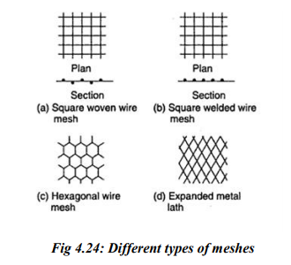

1. Skeletal Steel As the name implies this generally used for making frame work of the structural component upon which layers of wire mesh reinforcement are laid and also serve as spacer to wire mesh. The steel rods are provided in both longitudinal and transverse directions. In general, mild steel rods of galvanized iron wires of dia varying from 2mm to 6mm are used. Sometimes for structural purpose HYSD bars are also employed. 6. Admixtures Admixtures are additives, which are introduced in the cement sand mortar mix to modify the properties of the mortar in its fresh and hardened state. Construction Methods Ferro-cement does not required skilled labor nor heavy capital investment on equipment to produce them there are four major steps in ferro-cement construction, they are placing of reinforcement, mixing of mortar, placing of mortar and curing. As the reinforcement content in ferro-cement is very high up to 8% by volume and is uniformly distributed throughout the thickness of the element, the essential requirement is that the continuous mesh reinforcement has to be completely impregnated and covered with cement mortar. A number of techniques are being used for ferro-cement construction. Among these hand plastering of mortar from one side against a mould or from both sides. Casting Techniques of Ferro-cement There are 4 methods of casting techniques.

They are 1. Hand Plastering Paul and pama have developed three method of hand plastering (i) One stage technique: consists of single application of mortar from outside to inside of mesh and subsequently finishing off to a smooth surface before initial set take place.

(ii) Two-stage technique: In this process mortar is plastered from one side without fully penetrating through all the mesh layers and the outer surface is finished smooth and cured. Later the remaining portion is plastered with mortar. To assist in bond between the old and new mortar, cement grout is applied before second stage plastering is carried out on the old mortar. This technique is adopted when more than 5 layers of mesh is used. (iii) Sectional plastering: while undertaking plastering of large ferrocement structures, it may be preferable to plaster in sections using one stage technique, necessitating the need for construction joints.

2.Semi-mechanized process

• This system is termed as semi mechanized process because the mould can be rotated to facilitate the dashing of mortar. • This system is better than the other as better compaction can be achieved. • The advantage of this system is it does not require sophisticated equipment or electricity.

3. Centrifuging

• The centrifuging process is commonly adopted for the fabrication concrete cylindrical units. • Because of good compaction, the ferro-cement pipes casted by centrifuging can also be used for pressure pipes

4. Guniting

• The process of guniting can be adopted for applying the mortar to wire mesh system. • This process can be applied with experience gunman can give good compact and uniform surface. • This appears to be suitable process for mass production prefabricated units.

**Module – 5**

**9. a. What are the advantages and disadvantages of manufacturing concrete from RMC plants? (8Marks)**

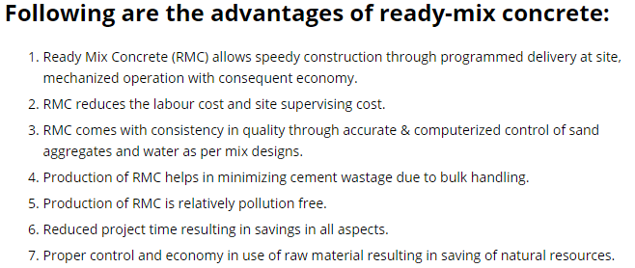

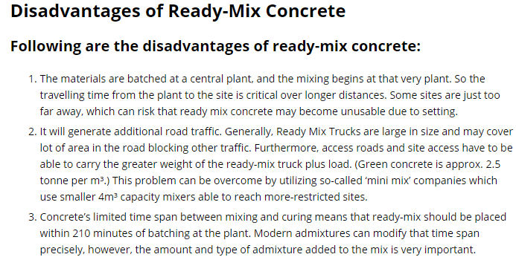

**9. b. What is the meaning of precast elements? What are the advantages of precast concrete?**

Precast concrete means a concrete member that is cast and cured at a location other than its final designated location. The use of reinforced concrete is a relatively recent invention, usually dated to 1848 when jean-Louis Lambot became the first to use it. Joseph Monier, a French gardener, patented a design for reinforced garden tubs in 1868, and later patented reinforced concrete beams and posts for railway and road guardrails.

**Advantages of Precast Concrete Construction**

Very rapid speed of erection

Good quality control

Entire building can be precast-walls, floors , beams , etc.

Rapid construction on site

High quality because of the controlled conditions in the factory

Prestressing is easily done which can reduce the size and number of the structural members.

**10. a. Write a note on:**

**(i) Types of concrete mixer.**

Machine Mixing Mixing of concrete is almost invariably carried out by machine, for reinforced concrete work and for medium or large scale mass concrete work. Machine mixing is not only efficient, but also economical, when the quantity of concrete to be produced is large. Many types of mixers are available for mixing concrete. They can be classified as batch mixers and continuous mixers. Batch mixers produce concrete, batch by batch with time interval, whereas continuous mixers produce concrete continuously without stoppage till such time the plant is working. In this, materials are fed continuously by screw feeders and the materials are continuously mixed and continuously discharged. These types of mixers are used in large works such as dams. In normal concrete work, it is the batch mixers that are used. Batch mixer may be of pan type or drum type. The drum type may be further classified as tilting, non-tilting, reversing or forced action type. As per I.S. 1791-1985, concrete mixers are designated by a number representing its nominal mixed batch capacity in litres. The following are the standardized sizes of three types: a. Tilting: 85 T, 100 T, 140 T, 200 T b. Non-Tilting: 200 NT, 280 NT, 375 NT, 500 NT, 1000 NT c. Reversing: 200 R, 280 R, 375 R, 500 R and 1000 R The letters T, NT, R denote tilting, non-tilting and reversing respectively. Normally, a batch of concrete is made with ingredients corresponding to 50 kg cement. If one has a choice for indenting a mixer, one should ask for such a capacity mixer that should hold all the materials for one bag of cement. This of course, depends on the proportion of the mix. For example, for 1 : 2 : 4 mix, the ideal mixer is of 200 litres capacity, whereas if the ratio is 1 : 3 : 6, the requirement will be of 280 litres capacity to facilitate one bag mix. Mixer of 200 litres capacity is insufficient for 1: 3: 6 mix and also mixer of 280 litres is too big, hence uneconomical for 1: 2: 4 concrete. To get better efficiency, the sequence of charging the loading skip is as under: Firstly, about half the quantity of coarse aggregate is placed in the skip over which about half the quantity of fine aggregate is poured. On that, the full quantity of cement i.e, one bag is poured over which the remaining portion of coarse aggregate and fine aggregate is deposited in sequence. This prevents spilling of cement, while discharging into the drum and also this prevents the blowing away of cement in windy weather. Before the loaded skip is discharged to the drum, about 25 per cent of the total quantity of water required for mixing is introduced into the mixer drum to wet the drum and to prevent any cement sticking to the blades or at the bottom of the drum. Immediately, on discharging the dry material into the drum, the remaining 75 per cent of water is added to the drum. If the mixer has got an arrangement for independent feeding of water, it is desirable that the remaining 75 per cent of water is admitted simultaneously along with the other materials. The time is counted from the moment all the materials, particularly; the complete quantity of water is fed into the drum.

**(ii) Cost concept in building. (8 Marks)**

Cost saving Techniques in Planning, Design & Construction Construction of home is always a complex task whether it is in planning phase or execution phase. At the time of the house construction there are many steps to be followed such as preparation of architectural drawings, structural drawings and obtaining approvals from concerned authorities etc. In most of the cases of home construction projects, the money runs out before the home is completed. This happens because the home owners do not have a stage by stage cost estimate, idea of building materials, knowledge of technical aspects etc. Home owners must know the ways or techniques where they can save unnecessary cost while construction of their home. No one wants to pay more than necessary when building a home. These techniques apply in both the scenarios whether you construct a house in your own guidance or supervision or you have assigned a contractor to do the job. So, following are some of the techniques or tips to save the cost of construction which keep your building budget within reason, without compromising on the home you want. These techniques includes complete schedule of construction, Detailed Bill of Quantity, Building Material Selection, Proper Planning of Architecture and Construction, Interior Designing, finishing etc.

**b. What are the equipments used for producing stabilized blocks? Explain them in brief. (8Marks)**

**Development of Soil Block Presses**

Since the quality and durability of soil constructions was generally compared with that of burnt brick masonry and more recently with concrete block structures, the compressive strengths achieved by manual compaction (by throwing or ramming) were not always satisfactory. In order to achieve higher compaction, mechanical devices were developed, both in the form of tampers, as well as in the form of block presses (first made out of wood, later out of iron or steel). The first documented block press was developed in France in 1789.

The earlier presses functioned mainly as ramming devices for dynamic compaction, eg with heavy covers (30 kg) which close down with great force, displacing the excess soil. Since the beginning of the 20th century press makers have been devising manual and motorized presses that make use of static force. One of the earliest machines, LA MADELON, is still being manufactured in Belgium, although with several modifications and under different names. But most of the older machines have disappeared from the market.

All these machines were relatively large, heavy and expensive, so that their use was limited. What was needed, was a small, light, simple and cheap block press, which could be used on the remotest building sites in the Third World.

According to these requirements, the Chilean engineer, Raul Ramirez, developed such a machine in 1956. He was then working with CINVA, the Inter-American Housing Center in Bogota, Colombia. The press was, therefore, called CINVA-Ram, whereby "Ram" was derived either from Ramirez, or from the English word for a compacting device.

The CINVA-Ram is now by far the best-known and most widely used block press. Numerous variations of it have been manufactured in many countries, but, in its original form, it still is the lightest and least expensive block press available - every improvement, in terms of handling, output and sturdiness, invariably means an increase in price.

In the 1950s and 60s, interest in soil constructions was generally low. In the 1970s, research work and implementation of soil technologies in development projects steadily increased, largely on account of the world-wide energy crisis. Apart from several other publications, Hassan Fathy's "Architecture for the Poor", which was published in 1973, did a great deal to revive interest in soil construction systems.

In the course of these developments, a new generation of soil block presses came into existence in the 1970s, namely complete production units on wheels. The equipment generally required for blockmaking, apart from the press, are a sieve, a mixer and a measuring scoop for charging the mould, although quite often these are substituted by manual operations and estimation of appropriate soil mix proportions and required quantity of mould filling. The new, partially or fully automatic machines accomplished all these tasks in quickly repeating operation cycles, thus achieving higher outputs of uniform, superior quality bricks.

Soil Block Presses Today

There are basically four types:

Manual presses: the moulding and turning out operations are carried out by the machine which is operated manually.

Motorized presses: the moulding and turning out operations are carried out by the machine which is power driven.

Mobile production units: the production unit is easily transportable and the moulding and turning out operations, the preparation of the raw material and/or the evacuation of the finished product are entirely automated.

Industrial production units: these production units are particularly difficult to transport but the entire process is automated. These units are not included in the Product Information.

ASTRAM

The ASTRAM Soil BlockMachine is the lightest soil block press with interchangeable moulds. It was designed in 1980 by Professor K.S. Jagadish of ASTRA (Indian Institute of Science, Bangalore), on the basis of laboratory studies on the relations between compaction force, human effort and output rate.

The welded, all-steel machine consists of a frame, a mould and a toggle lever mechanism. The mould is provided with a stiffened plate lid which. when closed. can be locked down with a bolt locking mechanism. A scoop is provided for measuring the correct amount of soil to fill into the mould.

The high position of the mould and the lever action being only on one side, greatly facilitate block production and reduce the physical strain on the workers.

Commercial production of the ASTRAM began in 1985 and the machine is now in use in almost all parts of India.

Operating the ASTRAM

With the lever in the vertical position, the base plate is at its lowest level and the mould ready for filling. Lubrication of the side walls of the mould is advisable to facilitate ejection of the blocks. While the soil mix, measured out in the scoop, is filled in by one worker, the second worker precompacts the soil in each corner with his fingers. Further precompaction is achieved by closing the lid with some force, and clamping it down.

Only one person is required to pull down the lever until it reaches the stop, when the base plate has moved up 6 cm. The lid is unclamped and opened, so that the lever can be pushed further down to eject the block, which can be easily removed for curing.