USN |  |  |  |  |  |  | 
Internal Assessment Test 3 – May 2018
Sub: |  | Ground improvement Techniques |  |  |  |  | Sub Code: | 15CV654 | Branch: |  | CIVIL
Date: |  | 2/7/2018 | Duration: | 3 hrs | Max Marks: | 80 | Sem / Sec: |  |  |  |  | OBE
Answer any FIVE FULL Questions one full question from each module |  |  |  |  |  |  |  |  |  | MARKS
Module 1
1 (a) | Classify the ground improvement techniques and their suitability.  Improvement of ground properties to the desired engineering performance using geotechnical processes is known as ground improvement. It includes increase of shear strength, decrease of compressibility and decrease of permeability. The following are some of the geotechnical processes:  - Compaction  - Drainage  - Chemical stabilization  - Mechanical stabilization  - Geosythetics  - Vibrations  - Grouting and Injections  The geotechnical process selected depends on  - The type of soil  - Type of Loading  - Area and depth to be improved  - Permissible total and differential settlement  - Availability of materials for improvement  - Economy  - Experience |  |  |  |  |  |  |  |  | [08]
(b) | If in a project unsuitable soil conditions are encountered, what are the possible alternate solutions of ground classification?  In case the soil available at site is not suitable then the following alternate approaches can be adopted.  - By pass the unsuitable soil by means of a deep foundation extending to a suitable bearing material.  - Redesign the structure and foundation for the additional loads caused which may not be economical.  - Remove the poor soil and replace it with a better soil.  - Treat the soil in place to improve its properties. |  |  |  |  |  |  |  |  | [08]
 | OR
2 (a) | Explain the effects of compaction on compressibility and permeability properties of soil.  Soils compacted at dry of optimum have flocculated structure while soils compacted at wet of optimum is of dispersed structure. At lower water contents force of attraction dominates while on the wet of optimum the force of repulsion dominates due to the presence of adsorbed water layer  PERMEABILITY  Permeability depends on the size of voids. On the dry side of optimum an increase of water content result in decrease of permeability. There is an improved orientation resulting in lesser voids and lesser permeability. The minimum permeability occurs slightly above OMC therafter permeability slightly increases but remain always less than that of dry side of optimum.  COMPRESSIBILITY  Soils compacted at the dry of optimum offers greater resistance to compression due to its flocculated structure and are less compressible than soils compacted at the wet of optimum. |  |  |  |  |  |  |  |  | [08]
2 (b) | With a sketch explain dynamic compaction.  This is a method that is used to increase the density of the soil when certain subsurface constraints make other methods inappropriate. A fill of non-homogeneous nature cannot be compacted by conventional methods. When a higher depth of improvement is needed dynamic compaction is adopted. The weight and the height of fall and the spacing determine the amount of compaction that would occur.  The impact of the free fall creates stress waves that help in the densification of the soil. These stress waves reduces the voids and densifies the soil. In cohesionless soils, these waves create liquefaction which is reduction of effective stress due to build up of pore pressures which are dissipated fast hence the soil recovers resulting in densification. Silty sands, silts and clays can be improved by compaction if the developed pore water pressures are allowed to dissipate. Hence most soil types can be improved with dynamic compaction. Old fills and granular soils are most often treated. The soils that are below the water table have to be treated carefully to permit emission of the excess pore water pressure that is created when the weight is dropped onto the surface. It is impossible to improve soft and sensitive clays by dynamic compaction.  The impact is done by a grid pattern such that the influence zone overlap to ensure the whole area is treated. Spacing of the grid depends on the following factors:  - Depth of compressible layer  - Permeability of soil  - Location of ground water level  Deeper layers are compacted at wider grid spacing while upper layers are compacted with closer grid spacing. Deep craters are formed by tamping. Craters may be filled with sand after each pass. Heave around craters is generally small.  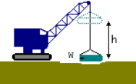
 | Module 2
3 (a) | Explain different types of dewatering techniques.  Open sumps and ditches  Sump is the name given for the shallow pits that are dug at corner of excavation. Along the periphery of the excavation there are ditches to collect water. This water flows from ditches to sumps. The flow of water is by gravity. Water is pumped out from the sumps.  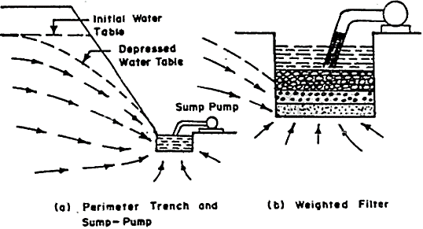  This is a simple method used for dewatering shallow excavations that have coarse grained soils or the soils that have permeability that is greater than 10-3 cm/sec.  Significant amount of seepage can result in formations of holes and depressions of the lower part of slope. This is due to the washing away of soil into the sump. The slump bottom may also be subjected to piping. This problems can be solved by the use of inverted filter that is of many layers. These have coarser material in successive layers from the bottom of the sump pit to the upward direction.  WELL POINT SYSTEM  Filter wells are small well screens of diameter and length of 0.3 m to 1 m.  Wellpoint dewatering involves installing a closely spaced line of small diameter wells alongside an excavation or a ring of wells around an excavation. Each well is known as a ‘wellpoint’ and is designed to be low in cost and robust in design and materials.  Typically each wellpoint is approximately 6 m deep and around 50 to 80 mm in diameter. The horizontal spacing between wellpoints is usually between 1 m and 3 m. The well points are made of brass or stainless steel screens or plastic. The lower section of each wellpoint has a perforated screen with unperforated liner in the shallower section above the screen and the top of each well is connected to the header pipe. A wellpoint pump, capable of pumping both air and water, is connected to the header main. The pump creates a partial vacuum in the header main, which acts to draw water through the wellpoint screen, up the wellpoint riser, through the header pipe and to the pump from where it is discharged. In this way a single wellpoint pump can act on many wellpoints simultaneously and can potentially lower groundwater levels over a wide area.  DEEP WELL DEWATERING SYSTEM  Why is it used?  This method is used when larger depths of water should be lowered or where water at artesian pressure should be removed.  What is it?  A deep well system uses bored wells, typically pumped by submersible pumps near the base of each well. Each well is connected to water collection pipes. Multiple wells are pumped simultaneously. This causes lowering of groundwater level and creates a cone of depression or cone of drawdown around the well over a wide area beneath an excavation.  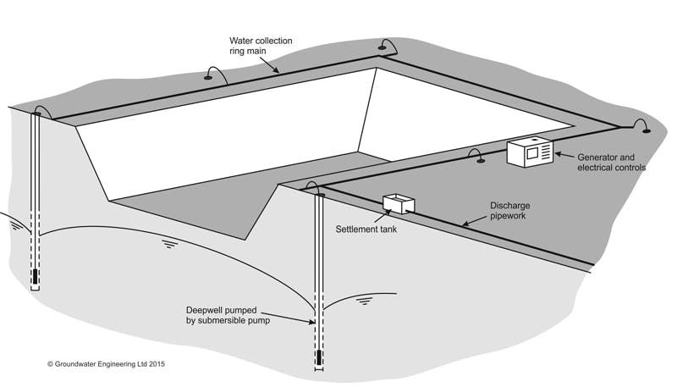  How wells are installed?  A bore hole of diameter 200-300 mm is dug by rotary drilling or percussion drilling methods. (borehole diameter should be larger than the well casing). The smaller size range is normal for low flow rate systems and the larger diameter wells are normally used for higher flow rate systems.  The size of well casing depends on the size of submersible pump. The well casing is inserted into the borehole. The well casing has a perforated screen at a level where dewatering is required. Below the perforated screen there is an unperforated portion which acts like a sump to collect any fine material which might be drawn through the filter. The graded filter is placed between the inner casing and the outer casing along the length of dewatering. Wherever filter is not there the space between inner and outer casing is backfilled. The backfilling or the filling of the filter is carried out in such a way that the outer casing is raised in stages while filling is done.  EDUCTOR DEWATERING SYSTEM  Done in areas of low permeability. Deep excavation of stratified soils. Vacuum is achieved by circulating high pressure water (from a tank and supply pumps at ground level) down small diameter supply riser pipes in the well to a nozzle and venturi located in the eductor near the base of each well. The high velocity as the water is forced through the nozzle creates a very low pressure (vacuum). This system works on the principle of forcing water at high pressure down the well and through a nozzle to create a venture effect, which in turn creates a vacuum of sufficiently high level to draw up the water surrounding the bottom of the well and return it to the surface. Venturimeter effect is the low pressure created when fluid passes through nozzles. The vacuum draws groundwater into the well where it combines with the circulating water and is piped back to ground level via a return riser pipe and thence through the reservoir tank at the surface and back to the supply pump for recirculation. The excess water pumped from the well is discharged from the system.  Because the technique does not rely on suction from the surface, it can generate much larger drawdowns of groundwater level than a wellpoint system. However, due to the limitations of equipment that is typically available (and upper limits on supply pressures) it is rare for eductor systems to be used where drawdowns are in excess of 60 m.  Eductor well dewatering can be very effective in low permeability soils (such as silts or silty sands or clays with a permeable fabric). In these cases the well yields can be very low, and it can be difficult to reliably operate a deep well system with submersible pumps, as the low flow rates may result in pumps burning out. The low flow rate capacity of eductors is well matched to such low well yields (eductors can operate at flow rates far below their rated capacity without risk of damage). |  |  |  |  |  |  |  |  | [08]
3 (b) | Explain electro osmosis technique of dewatering and stabilization technique. What is the purpose of replacing electrodes during electro-osmosis dewatering.  DEWATERING BY ELECTRO- OSMOSIS  Electro-osmotic method is used when co-efficient of permeability lies between 10-7 cm/see to 10-5cm/sec. In electro-osmotic method, two electrodes are driven into the saturated cohesive soil. The cathode is made out of steel in the form of a well point or a tube. A steel rod or a pipe or a sheet piling is made to serve as anode.  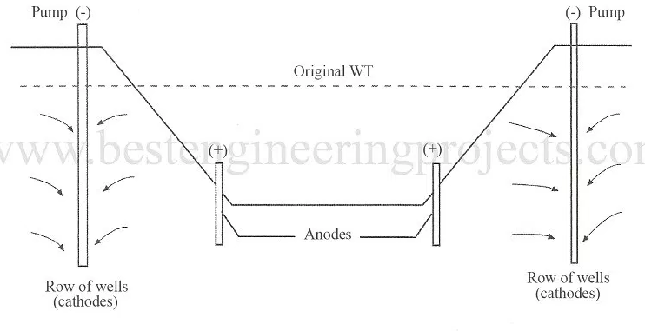  In general the surface of soil is negative charged and is surrounded by polar water and ions of other elements. When a current is passed through the soil, the positively charged ions on the surface are attracted towards cathode. During electro-osmosis process the attracted positively charged ions take the water of the double layer with them. The direction of flow is reversed and water is collected in the well point made of cathode. The collected water is pumped out.  The first layer is adsorbed cations. The second layer is the water molecules around the adsorbed cations. When anode and cathode are installed as shown in figure the electromotive force between the two electrodes in soil, attract the adsorbed cations and the water molecules attached to the cations to the cathode (negatively charged electode). The free water is also carried to the cathode by viscous flow. Thus if cathode is made as a well water gets collected in the well. Electro-osmotic transport of water through a clay is a result of diffuse double layer cations in the clay pores being attracted to a negatively charged electrode or cathode. As these cations move toward the cathode, they bring with them water molecules that clump around the cations as a consequen ce of their dipolar nature. In addition, the frictional drag of these molecules as they move through the clay pores help transport additional water to the cathode. The macroscopic effect is a reduction of water content at the anode and an increase in wate r content of the clay at the cathode.  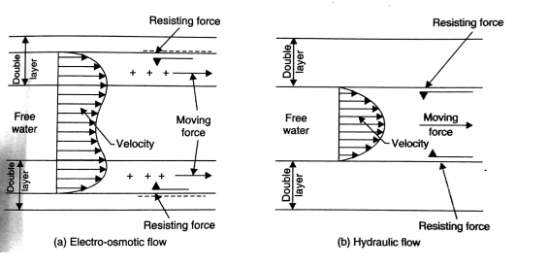  Discharge collected in this way?  Q = ke ie A  How the electrodes are arranged?  The general layout of the electrodes depends on the purpose for which they are intended. Anodes can be old pipes, of 25 mm or 50 mm diameters, which can be easily driven into the soil.  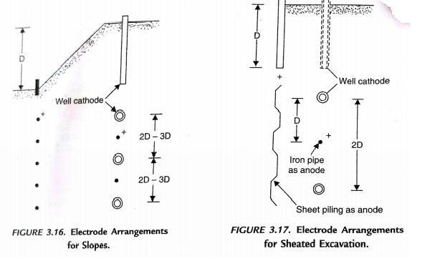  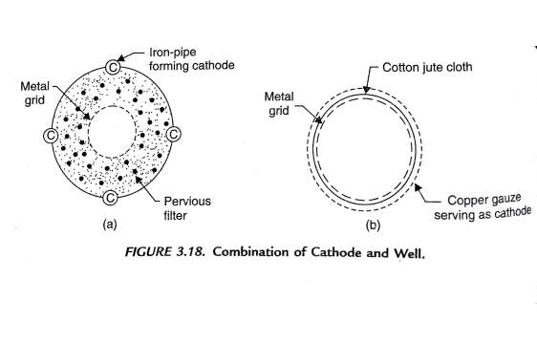  The cathode and the well can be arranged in two ways as shown.  - Well is arranged in close proximity to the cathode  - Cathode and the well combined as one body  The copper gauze acts like cathode.  The cathodes should be of the entire heigth of the excavation. Allowing water to flow into the cathode along the entire heigth. Anode and cathode should reach till equal depths. They both should extent 1.5 m below the slope. IS code suggest cathodes be placed at centre to centre distance of 7.5 m to 10 m, with anodes installed midway between them. The cathode wells should have diameter not less than 100 mm. |  |  |  |  |  |  |  |  | [08]
 | OR
4 (a) | With a neat sketch, explain preloading technique with vertical drains of ground improvement techniques.  PRELOADING  Preloading is applying an external load (surcharge) for a long duration till the soil is consolidated to the desired level. Preloading is done to achieve the settlement due to the external load before construction itself such that after construction the settlement is negligible. We are in fact making the soil over consolidated by preloading. Preloading is done before the construction of a structure or after a structure is constructed (like in liquid storage tank sites).  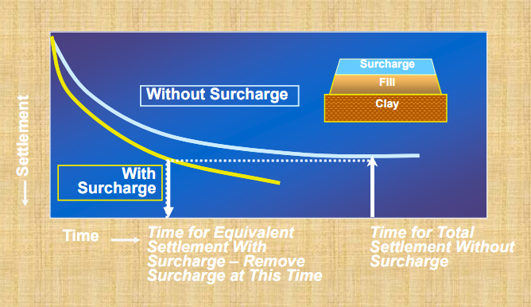  PRECOMPRESSION PRINCIPLES  Preloading causes increase in excess pore water pressure initially. The pore water pressure dissipates gradually causing an increase in effective stress which in turn causes settlement. The preloading applied by means of a fill should produce a stress atleast equal to the load of the final structure. The time required for attainment of full consolidation is directly proportional to the square of the thickness of the layer and indirectly proportional to the permeability of the layer.  The ratio of weight of preload to the weight of the final structure is known as coefficient of surcharge (ms). Higher the ms results in:  - lesser the time required for consolidation  - higher the post –preloading factor of safety against base failure.  - More construction time  - More expense  - More attention required for stability  Generally ms varies from 1 to 2.  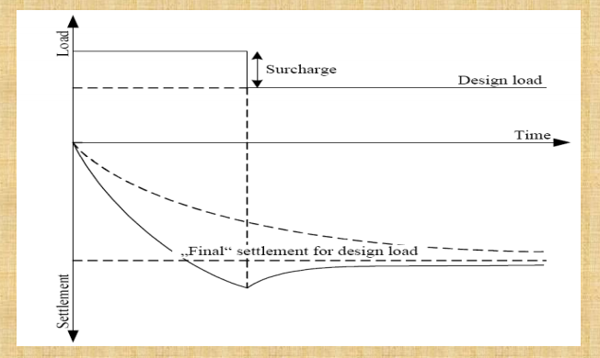  The design of a preload includes:  - The amount of surcharge.  - Loading period  Surcharge fills causes  - Primary consolidation  - Secondary consolidation More in peats  The degree of consolidation varies with depth. The surcharge duration should be based on the desired level of consolidation achieved at the points farthest from the drainage boundaries.  The advantages of preloading are as follows:  - Economical  - Fill material used for preloading can be used for site preparation later.  - Only earth moving equipments are required.  - Cost of monitoring preloading is less and the instruments for monitoring can be installed within very less time.  - Effect of preloading can be observed periodically from field-instrumentation and future prediction can be made of the behavior.  - Provides uniform improved properties of soil.  Preloading should be adopted only in the following conditions:  - There shouldn’t be any base failure on placing the preload.  - The duration of preloading should be within the construction schedule.  - There will be no damage to the adjoining structures.  - No undue disturbance to nearby communities.  - Thickness of layer to be consolidated is less.  Note: after the structure is built the settlements should be within the desired range.  VERTICAL DRAINS  Preloading becomes insufficient when the thickness of the strata to be drained is very large or when permeability is very low making consolidation by preloading a time consuming process. Just like when we preload we put sand blanket under the preload to collect water from the clay layer and drain it laterally vertical column of sand can be incorporated in the clay layer to reduce the drainage path thus reducing the time for consolidation.  GENERAL PRICIPLE OF VERTICAL DRAINS  Vertical drains are continuous vertical columns of pervious sand. They are patheways for porewater to escape. Drainage path is the shortest route for water to escape. Drainage path is reduced in the case of vertical drains. Vertical drains in conjunction with preloading cause rapid dissipation of porewater therby accelerating primary consolidation. Vertical drains do not accelerate secondary consolidation but it can lead to early occurrence of secondary consolidation.  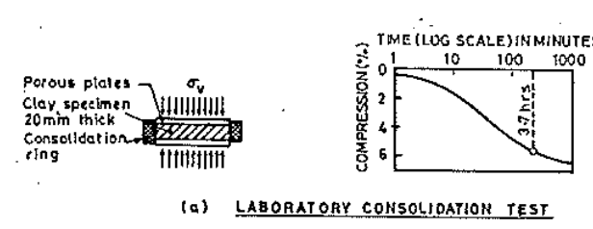  c  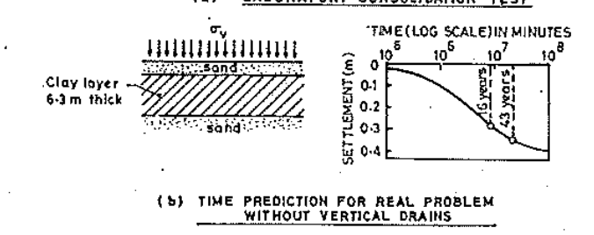  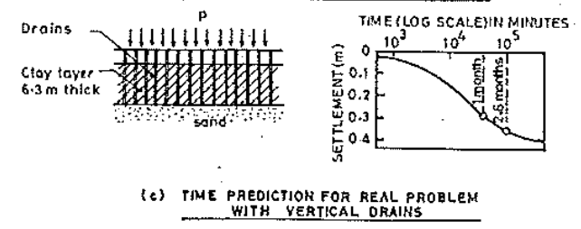  In the figure above we can see that  Time taken for primary consolidation = 3- 4 hours  Time taken for primary consolidation on field of 6 m thick strata of having double drainage = 43 years  Time taken for the same 6 m thick soil with vertical drains = 2-6 months  Vertical drains are unnecessary in the following cases:  - When the clayey soil is having sufficient permeability.  - Clays with pervious inclusions  - Sensitive clays; as vertical drains tend to disturb the soil resulting in high initial pore water pressure and reduce the shear strength of the soil around the drain.  - When time required to install vertical drains is not much different from the time saved by accelerating consolidation  - Increases the cost 3 times hence unnecessary when trying to reduce cost. |  |  |  |  |  |  |  |  | [08]
4 (b) | Why drainage of slopes is necessary? Give reasons.  The provision of slope drainage is an important part of ensuring the future stability of a slope. To clarify, it reduces groundwater levels and allows water to run off without causing damage to the slope or facilities below.  If slopes aren’t drained it reduces the shear strength of the soil cause slip along potential failure slip circles.  Improper slope drainage triggers landslides.  Uncontrolled water flows on the slope area can cause erosion. The sensitive soil types for erosion are silt, silty moraine and sand. Progressive erosion can lead to failure of the entire slope. Vegetation can reduce erosion.
 | Module 3
5 (a) | Discuss short term and long term soil-lime reaction, when lime is used as a stabilizer and what are the engineering benefits of lime stabilization.  - Lime is obtained from limestone. Following are the various forms of lime:  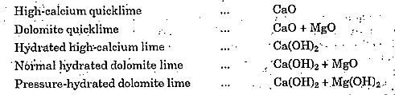  - Slaked lime Ca(OH)2 is most commonly used for soil stabilisation.  - Slaked lime is formed by the hydration of quicklime.  - Quicklime is in the form of a coarse grain powder.  CaO + H2O = Ca(OH)2 + HEAT  - There is volume increase in the above reaction.  - On site slaking process create lot of steam.  - Quicklime is more suitable for transport as volume increase if it hydrates to slaked lime.  - Lime can be added with any admixtures like flyash or cement.  - Lime is not applicable for improving gravels or sands.  SOIL-LIME REACTIONS  HYDRATION  - Quicklime will react with water in the soil.  - This drying action is good in moist clays.  - If lime is placed as columns this hydration reaction will enhance consolidation as volume increase is there in this reaction.  - CaO + H2O = Ca(OH)2 + HEAT  FLOCCULATION  - The Ca ion replaces the cation adsorbed on the clay minerals.  - This affects the way the structural components of the clay minerals are connected together and hence cause the clay to flocculate.  - Clay’s plasticity is reduced thus increasing its strength and stiffness.  CEMENTATION  - The second stage of clay-lime reaction removes silics from clay mineral lattice to form products like those of cement hydration.  - Cementation provides the strength.  - The higher the surface area more effective is this process.  - Once the silica is used up there is no improvement in strength. Hence the percentage of lime added should be such that it uses up the available silica.  - Too much of lime will have a negative effect.  CARBONATION  - Lime reacts with carbon dioxide in the voids to form a weak cementing agent CaCO3. The calcium carbonate formed will not react any further.  SUITABILITY OF LIME STABILISATION  - Lime is primarily used for treatment of clayey soils.  - It is not very effective for cohesionless soils unless used along with flyash, furnace slag etc.  - A soil where lime treatment leads to cementation is known as “reactive” soil.  - The most reactive clays are those containing montmorillionite with a high base exchange capacity.  - A quick indication of reactivity can be measured by proctor needle test on original and sample treated with lime (there will be a good difference in penetration).  - Another test is by immersing the original and treated soil in water. The treated soil will not disintegrate and will maintain the shape indicating cementation.  ENGINEERING BENEFITS OF LIME STABILISATION  - The workability of the clay is improved making it easier to mix and compact.  - The plasticity of the soil decreases as plastic limit increases. (The liquid limit may increase or decrease depending on the type of soil).  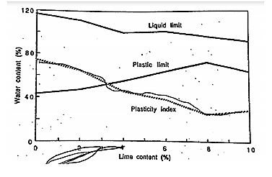  - Lime increases the OMC which is advantageous when dealing with wet soil.  - Flocculation makes compaction difficult hence the maximum dry density obtained decreases for a compactive effort.  - The compaction curve for lime treated soil is flatter making moisture control less critical.  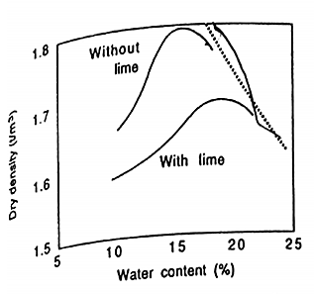  - The delay in compaction doesn’t affect lime stabilisation as cement stabilisation.  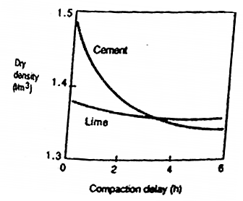  - It increases the UCS and CBR values for clay.  - UCS improvement depends on  - Height diameter ratio of the sample  - Density or compactive effort  - Water content  - Curing time  - Temperature and humidity during curing  - Type and amount of lime  - Modulus of elasticity, cohesion and angle of friction increases with lime percentage.  - Tensile strength develops at high lime percentages.  - Lime reduces shrinkage and swelling.  - An increase in permeability could mean better drainage and less pore water pressure buildup under load. Too high permeability may lead to softening of the unstabilised soil below. Lime increases the pore size as it makes the soil floacculated thus permeability increases. |  |  |  |  |  |  |  |  | [08]
5 (b) | Describe cement stabilization. What are the engineering properties of cement additives to soil as stabilizer?  - The binding of soil particles without alteration is known as cementing.  - Portland cement stabilizes soil by “cementing”.  - Cement blended with soil and water is known as soil-cement.  - The cement reacts with the siliceous matter in soil to cause cementing.  - The physical properties of soil cement depends on:  - The type of soil  - Type of cement  - Amount of cement  - Placement and curing conditions  SOIL CEMENT WATER REACTION  - The reaction of cement and water forms cementitious calcium silicate and aluminium hydrates, which bind soil particles together.  - The hydration releases Ca(OH)2, slaked lime, which in turn may react with soil components.  - Hydration of cement is independent of the soil type and hence cement stabilisation is effective for many soils.  TYPE OF SOIL WHICH CAN BE TREATED WITH CEMENT  - All inorganic soil that can be pulverised.  - Organic content reduces the strength of soil cement.  - The maximum per cent of organic content that can be present is limited to 2%.  - Soils with more specific surface area need more cement for stabilisation.  - Angular particles have more specific surface area than spherical particles.  - Soil with angular particles need less cement compared to soil with spherical particles.  - Presence of clay makes pulverising, mixing and blending difficult.  - Expansive clays are difficult to be treated.  - In clays cement stabilisation depends on exchangeable ion.  - A favourable exchangeable ion for cement stabilisation is Ca2+.  - Therefore lime or calcium chloride is added to clays before cement stabilisation.  - Cement stabilisation is difficult in highly plastic clays as mixing is difficult.  - Presence of certain salts like sulphates affect the structure of soil cement as these salts will crystallize in the pores affecting the strength of soil-cement.  - Best results are obtained with well graded soils with per cent fines <50 % and plasticity index < 20 %  The basic processes involved in construction with soil cement:  - Pulverising  - Mixing  - Compacting  - Curing  PULVERISING OF SOIL  - At the end of soil cement should not contain lumps.  - Hence the soil before the process starts should be well mixed.  - Pulverisation can be improved by slower speed of the mixing vehicle, by additional passes and by replacing the worn mixer teeth.  - The soil with high moisture content won’t mix well with cement.  - In no case the moisture content of soil should be more than its OMC before cement spreading.  Mixing  - A proper quantity of cement is being spread over the soil.  - They are mixed homogeneously.  - Then measured water is added and mixed thoroughly. The mixing can be done by several hand mixing equipment or machines.  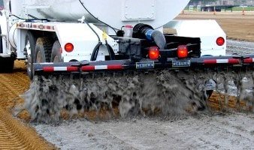  Cement Laid Over Prepared Soil Subgrade  Compaction  - The soil cement water mixture is well compacted at Optimum moisture content of the soil with a suitable compaction equipment for the soil.  - Once done, the whole mixture layer is cemented permanently at a very high density resulting in less settlements.  Curing  - After compaction the soil should be finished as per requirement.  - The last step is curing which is performed to prevent evaporation of water to the atmosphere.  - This is done by spraying very small amounts of water and covering the soil with an impermeable membrane (plastic), straws or bitumen.  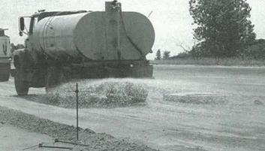  AMOUNT OF CEMENT  - The amount of cement depends on the type of soil.  Type of soil Percentage cement by weight  Gravels 5 to 10 % Specific surface area increases  Sands 7 to 12 %  Silts 12 to 15 %  Clays 12 to 20 %  ADMIXTURES FOR SOIL CEMENT  - Addition of any chemicals to soil-cement to improve the strength of soil cement can be termed as an admixture.  - The admixture that can be used in soil-cement can be:  - Lime  - Calcium chloride  - These admixture reduce the amount of cement to be used.  - These admixture helps the use of cement stabilisation of organic soils. |  |  |  |  |  |  |  |  | [08]
 | OR
6 (a) | Explain how fly ash is beneficial in combination with other materials for effective stabilization.  STABILISATION WITH FLY ASH  - Fly ash is the waste product created by the combustion of coal.  - It is of light to dark grey powder of silt size.  - Making use of fly ash for soil stabilisation may reduce pollution on land. But it pollutes the soil as it may contain heavy metals which may leach in to the ground water and also it destroys the vegetation (this aspect is not well investigated till now).  - Flyash by itself has got no cementitious properties but in presence of moisture it reacts to form cementitious materials if lime is present.  - Therefore flyash alone is not used for soil stabilisation but it is used in combination with cement or lime.  - By adding flyash to soil we are supplementing soil with silica and alumina so they can react with lime to form CSH gel and CAH gel.  PROPERTIES OF FLYASH  CHEMICAL COMPOSITION AND REACTIVITY  - The principles chemical constituents are the following  - Silica (SiO2)  - Alumina (Al2O3)  - Ferric oxide (Fe2O3)  - Calcium oxide (CaO) (less amount)  - Minor chemical constituents are  - Magnesium oxide (MgO)  - Titanium oxide (TiO2)  - Alkalies (Na2O and K2O)  - Sulphur trioxide (SO3)  - Phosphorous oxide (P2O5)  - Carbon  - Fly ash is a heterogeneous material whose properties depend on:  - Coal type and its purity  - Degree of pulverization  - Boiler type and operation  - Collection (ash collected at bottom or by electrostatic precipitator)  - Cementitious calcium silicate hydrate and calcium aluminosilicate hydrates are formed when glassy component of fly ash (3AL2O3. SiO2 or mullite) react with water and lime. Lime will react with water to form calcium hydroxide which will react with the pozzolan to give cementitious materials. This is known as pozzolanic activity.  - Pozzolans are a broad class of siliceous or siliceous and aluminous materials which, in themselves, possess little or no cementitious value but which will, in finely divided form and in the presence of water, react chemically with calcium hydroxide at ordinary temperature to form compounds possessing cementitious properties. Fly ash is an example of a pozzolan which exhibits pozzolanic activity.  - Critical to the pozzolanity of fly ash are the following conditions:  - Amount of silica and alumina in the fly ash.  - Presence of moisture and lime  - Fineness of fly ash  - Low carbon content  - There are two types of fly ash:  - Class F fly ash  - The burning of bituminous coal produces Class F fly ash.  - Contains less than 7% lime (CaO).  - Possessing pozzolanic properties  - Requires a cementing agent, such as Portland cement, quicklime, or hydrated lime—mixed with water to react and produce cementitious compounds.  - Class C fly ash  - Fly ash produced from the burning of sub-bituminous coal  - Also has some self-cementing properties.  - In the presence of water, Class C fly ash hardens and gets stronger over time.  - Class C fly ash generally contains more than 20% lime (CaO).  ENGINEERING PROPERTIES OF FLY ASH  - The specific gravity of fly ash is from 1.9 to 2.5.  - Fly ash is non-plastic and cohesionless when dry.  - Friction angle of fly ash ranges from 200 to 400.  - Dry density = 1.9 g/cc  - OMC = 30 % to 15 %  - Permeability tend to be low.  BEHAVIOUR OF FLYASH WHEN AN ADDITIVE IS ADDED  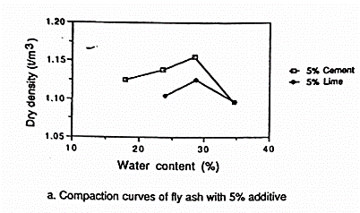  - Flyash when compacted with 5 % cement the maximum dry density obtained is higher than the maximum dry density obtained when 5 % of lime is added.  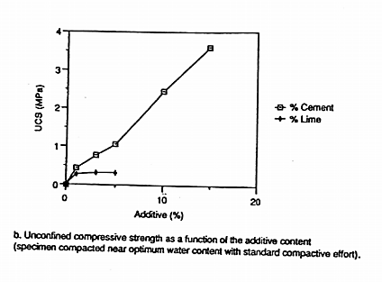  - The unconfined compressive strength of fly ash increases with % increase in cement.  - The unconfined compressive strength of fly ash increases with % lime but reach a constant value once the silics and alumina in fly ash gets used up.  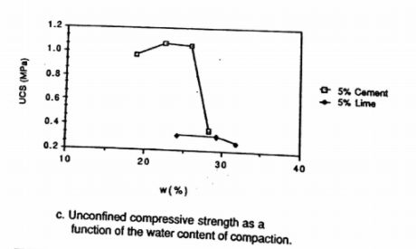  - The unconfined compressive strength increases with water content till the optimum water content and then it decreases.  - This curve is flat for flyash with lime. |  |  |  |  |  |  |  |  | [08]
6 (b) | Write short notes on  - Chlorides stabilization  Calcium chloride CaCl2  Physical properties  - Hygroscopicity – it attracts and absorbs moisture from the atmosphere. 1 kg of CaCl2 absorbs more than 4 kg of water.  - Deliquescence – it liquefies in moisture by its own absorption.  - Solubility – it is highly soluble in water. The solubility increases with temperature.  - Vapour pressure –tendency of a substance to change in to vapour state, at the same temperature and humidity the vapour pressure of the CaCl2 is less than that of water.  - Surface tension – CaCl2 has more surface tension than water.  - Freezing point – A lower freezing point than water.  EFFECT OF CaCl2 IN SOIL  - The Ca2+ ion replaces the cations on clay surface.  - This creates more repulsion between clay particles creating the structure more flocculated.  - Reduce the thickness of diffused double layer.  - It reduces the plasticity of soil.  - It increases the strength of soil.  - It changes the characteristics of water present in the pores.  - CaCl2 present in water in the pores lowers the rate of evaporation as CaCl2 has got lower vapour pressure than water.  - CaCl2 is hygroscopic and deliquescent and hence the moisture lost from the pores is less.  - Thus it reduces evaporative losses from soil.  - Hence used for moisture control during construction.  - It helps in control of dust generated from unpaved roads as it reduces visibility as well as the fines which provides cohesion isn’t lost ( this is the most appreciated use of CaCl2).  - Frost heave is reduced as the salt reduces the freezing point of water.  - All the improvement remain only if the salt remains in the pore water. If it is washed off the benefits due to salt in pore water is lost.  - It damages vegetation and will leach downward.  - In cold regions CaCl2 is used for faster thawing for frozen soils and thus it makes compaction possible.  - The strength reduction after repeated freeze thaw cycles is less for CaCl2.  - It can be a useful additive for cement and lime stabilization. (it supplements with Ca2+ ions).  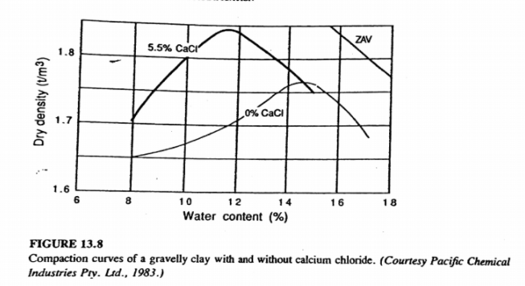  - The maximum dry density increases and OMC decreases in the gravelly clay due to the following factors:  - CaCl2 increases the surface tension of moisture films aiding compaction.  - CaCl2 causes flocculation making compaction difficult.  - Here the collective effect is CaCl2 has aided the compaction but this cannot be generalized as it depends on the soil.  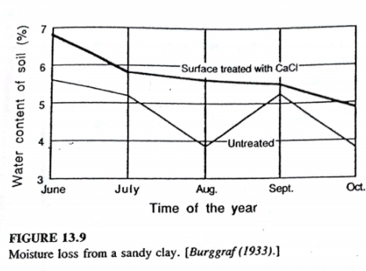  - Please note CaCl2 is generally used for moisture control than for strength. IN SOME CASES STRENGTH DECREASES (Brandl).  SODIUM CHLORIDE (NaCl)  - Has similar properties to CaCl2.  - Cheaper than CaCl2.  - Overall benefits are rated lower than CaCl2.  - IN SOME CASES STRENGTH DECREASES (Brandl).  - Bitumen stabilization  BITUMEN STABILISATION  What is bitumen stabilization?  - The stabilization of soil by bitumen, tar and asphalt is known collectively as bitumen stabilization.  What is bitumen asphalt and tar?  - Bitumen is a black viscous mixture of hydrocarbons.  - Bitumen is formed by processing the residue that remains after the evaporation of crude oil.  - Tar is the result of destructive distillation of coal.  - Destructive distillation is the process of heating a substance in a closed environment and collecting the volatile constituents.  - Asphalt is a mixture of bitumen with any inert material.  How bitumen is added to soil?  - Bitumen is usually added into soil as an emulsion or cutback or as hot bitumen. Bitumen is not directly mixed in to soil because of its high viscosity. Hence viscosity is reduced by making it an emulsion or cutback or as hot bitumen. Mixing in emulsion or cutback reduces pollution.  Bitumen added to soil as emulsion  - Bitumen emulsion is a mixture of water and bitumen. Bitumen is not soluble in water on its own. That is why an emulsifier is added.  - Addition of emulsifier with water facilitates breaking of bitumen into minute particles and keeps it dispersed in suspension.  - The production of bitumen emulsion consists of two primary steps.  - In the 1st step water is mixed with appropriate emulsifying agent and other chemicals.  - The 2nd step is the addition of bitumen with the water-emulsifier mix. This is done in a colloidal mill.  - Water-emulsifier mix and bitumen is pumped to a colloidal mill. The colloidal mill breaks the bitumen into tiny droplets.  - Emulsifier creates a coating of surface charge around the bitumen droplets that helps to keep these tiny particles away from each other. It also helps to keep these particles in a dispersed form.  Bitumen added to soil as cutback  - In cutback bitumen suitable solvent is used to lower the viscosity of the bitumen. The solvent used are naphtha, kerosene and diesel oil. Here the bitumen is thinned by the volatile oil.  - Once in soil, as the volatile evaporates the bitumen is deposited in soil.  - Higher the volatile solvent (volatile oil) lower is the viscosity and it is easier to mix but curing time reduces.  Bitumen added to soil as hot bitumen  - Heating bitumen to reduces its viscosity hence hot bitumen is also an option.  How bitumen stabilizes the soil??  - Bitumen stabilizes the soil by binding the soil particles. The bitumen coats every particles creating cohesion. (Predominant effect in cohesion-less soil as they need an increase in cohesion).  - Bitumen makes the soil water proof thus protecting the soil from the deleterious effects of water. It binds clays in small clods (due to natural cohesion the bitumen cannot coat each and every particle) and plugs the voids. (Predominant effect in cohesive soils as they need protection from water). The loss of strength due to increase of water is reduced. The quantity of bitumen required increases with the clay content. Soils having same clay content but different water affinity may require different amount of bitumen emulsions.  What are the final bitumen stabilized products?  - The product of bitumen stabilization is referred as :  - Soil bitumen – a water proof cohesive soil  - Sand-bitumen – sand particles cemented by bitumen (maximum strength achieved is achieved when 3 to 4 % bitumen is added).  - Water proofed granular soils – a well graded soil with some low plastic fines, water proofed with small amounts of bitumen (1 to 2 %).  - Oiled earth – a bituminous emulsion or cutback is sprayed on soil surface providing water and abrasion resistance.  What are the processes of obtaining bitumen?  - Vacuum distillation - distillation of a liquid under reduced pressure, enabling it to boil at a lower temperature than normal.  - High temperature pyrolysis – decomposition brought by high temperature  Type of soil?  - Best results occur in following type of soil  - Maximum particle size less than one third of the compacted thickness of the treated layer.  - Greater than 50 % finer than 4.75 mm  - 35 to 100 % finer than 0.42 mm  - Greater than 10 % and less than 50 % finer than 0.075 mm  - Liquid limit less than 40 %  - Plasticity index less than 18 % (Highly plastic there is difficulty to mix).  - Organic matter is detrimental to bitumen stabilization.  - Not effective in fine grained soil of high pH.  Amount of bitumen to be added  - The bitumen added to cohesion-less soils improve the strength as cohesion is improved.  - The bitumen added to clay doesn’t increase the strength but improves its water proofing ability.  - There is an optimum percentage of bitumen that can be added otherwise the fluidity of soil will increase making compaction difficult.  Compaction  - A soil asphalt mixture is the strongest at its at its maximum density.  - The OMC of soil asphalt is not the same as soil alone.  - The OMC is reduced to take into the lubricating effect of cutback or emulsion or Moisture content at fluff point.  - The density of soil stabilized with bitumen depends on the volatile content of bitumen and the type and amount of compaction.  - Higher the volatile content lower the strength.  Compaction for soil stabilized with cutback bitumen  - The amount of cutback required and hence maybe the volatiles for maximum strength maybe less from that required for most efficient mixing.  - Curing of the soil bitumen is done by allowing some time so that the volatiles can evaporate.  - This time is provided between mixing and compaction as well as after compaction.  Compaction for soil stabilized with cutback bitumen  - Bituminous emulsions are generally added in places where drying take place faster.  - Bitumen emulsions are droplets of bitumen in water.  - These bitumen gets deposited in soil when they coagulate or break.  - In places where drying needs to be accelerated, lime is added so that emulsion breaks due to heat of hydration.  - The OMC is below that moisture content for efficient mixing.  CURING CONDITIONS  - Curing is the process in which bitumen or asphalt increases its consistency as it loses solvent by evaporation.  - The longer the period of cure and warmer the temperature more is the volatiles lost.  - The strength of the soil bitumen is inversely proportional to the amount of volatiles present. |  |  |  |  |  |  |  |  | [08]
 | Module 4
7 (a) | Explain Blasting method of stabilization. Bring out the advantages of this method.  BLASTING  - In this method certain amount of explosive is buried at a certain depth of a cohesionless soil and it is detonated.  - Shock waves are produced which cause densification.  - A pipe of 7.5 cm to 10 cm diameter is driven in to the ground.  - Sticks of dynamite and an electric detonator are wrapped in waterproof bundles and lowered.  - The casing is withdrawn.  - A pad of wood is placed over to prevent misfire.  - The hole is backfilled with sand so that soil will experience full force of the blast.  - The charge is fired.  - A series of such holes with charge are kept ready and are detonated in succession.  - Usually the explosives are arranged in the form of a horizontal grid.  - As the depth of densifying increases the size of charge required also increases.  - The horizontal spacing depends on the following-  - Depth of strata to be densified.  - The size of charge.  - Overlapping of the charges.  - A spacing of 3 m to 8 m is typical and a spacing less than 3 m should be avoided.  - If the depth of densification is less than 10m or 10 m then the blasting can be done one tier (that is only one row at a particular depth). In this case the charge should be kept at a depth below half the depth of the strata to be densified.  - If the depth of densification is more than 10 m more than one tier is required.  - The depth of the charge should be greater than the radius of influence.  - Successive blasts of small charges at appropriate spacings are likely to be more effective than a single large blasts.  - The blast densifies the soil surrounding adjacent soil and the soil beneath the blast.  - The uppermost portion of the stratum may be less densified which are compacted by vibratory rollers.  - The amount of charge to be used should be optimal such that it is just enough to shatter the soil mass uniformly but not to create permanent surface craters.  - A carefully placed charge in required amount and depth will not create a surface heave of more than 0.15 m.  - The weight of charge required is calculated from the following relationship:  W = 164 CR3  W = weight of the explosive (N)  C = coefficient (depends on detonator)  R = radius of influence  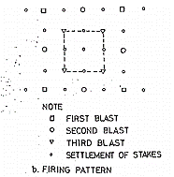  - Settlement stakes are placed to find the surface settlement produced due to blasting.  Advantages  - Less time, labour and expense.  - Can improve upto a depth of 20 m.  - Relative densities of 70 % to 80 % are obtained.  - Preferable in remote areas where vibrations are not an issue.  Disadvantages  - Stabilization tend to be non-uniform.  - Damage to adjacent structures  - Not applicable in cohesive soils.  - Not applicable in partially saturated soils. (pre-flooding can be adopted for this soil.  Data required  - Type of soil  - Degree of saturation  - Degree of densification  Data to be decided  - Spacing  - Depth  - Amount of charge  - Sequence of firing |  |  |  |  |  |  |  |  | [08]
7 (b) | What are stone columns? Explain the process of installation.  STONE COLUMNS  - Also known as granular piles.  - Installed by vibration techniques.  - A cylindrical vertical hole is made.  - Backfill is placed in increments in the hole and compacted.  - This displaces the backfill radially.  - The backfill is gravel of size 12 mm to 75 mm.  - The compacted backfill (gravel) forms well compacted stone columns.  - Stone columns are used to improve cohesive soil.  - They replaces the cohesive soil.  - Suitable for soft inorganic soils.  - Unsuitable in peat.  - Stone columns help in dissipating the exess pore water pressure and thus helps in consolidation of the surrounding soil.  - Stone columns are built to support isolated footing, strip footing or mat foundations.  - The entire foundation area is covered by sand blanket of 0.3 m thick to evenly distribute load and to facilitate the drainage of water conducted out of the soft soil and up the columns.  - Hence stone columns act as vertical drains as well as reinforcing elements.  - The increase in undrained shear strength of the surrounding soil is not considered in the design.  Stone column formation by vibroflot  - The vibroflot is allowed to sink in to the ground by its own weight.  - The sinking is assisted by jet of water or Compressed air.  - The soil surrounding the vibroflot is disturbed.  - The soil from borehole is removed by jetting water.  - Compressed air is used in partially saturated soils while water is used in fully saturated soils.  - The result is formation of a borehole of diameter larger than the vibroflot.  - While backfilling the vibroflot is raised.  - The vibroflot is re-penetrated and the backfill is compacted.  - The procedure is repeated till the hole is completely filled and compacted which forms a cylindrical granular pile.  Stone column by ramming  - It primarily uses a hammer weighing 15 to 20 kN.  - The hammer is dropped from a height of 1 to 1.5 m.  - Here hammering or ramming is used to compact the backfill in the pre-bored holes.  - The resulting stone column is known as rammed stone column.  - The technique is economical compared to vibroflot technique.  Stone column by auger method  - The bore-hole is made by spiral auger.  - The borehole is cleaned manually.  - In the cleaned boreholes granular piles are cast using 20 to 30 mm size stone aggregates and 20 to 25 % of sand with uniformity coefficient of 2.  - The aggregate and sand layers are placed alternatively with layer thickness of 300 to 500 mm and 50 to 100 mm respectively.  - Each two layer unit is compacted with sand layer at top is compacted with the help of a cast iron hammer.  - The cast iron hammer has a weight of 1.250 Kn with a free fall of 750 mm.  - Due to the impact the sand fill the aggregate voids causing lateral and downward displacement.  - Granular piles of 600 mm diameter and 15 m depth has been successfully installed.  SPACING OF STONE COLUMNS  - Spacing is determined by the settlement allowed to the loads applied later on and the degree of densification required.  - Stone columns are spaced at 1.2 m to 3 m on center over the site.  - Spacing ranges recommended for sand piles can be adopted for granular piles.  LENGTH OF STONE COLUMNS  - The length of the stone column is given below on the assumption that the total load taken up by the stone column is shared by end bearing resistance and the skin friction.  Load taken by skin friction = curved surface area * side cohesion  = П × d × Lc × c  Load taken by end bearing = bearing capacity * cross – sectional area  = c pt Nc × Ac  Total load on stone column $≤$ Load taken by skin friction  +  Load taken by end bearing  P $≤$ П × d × Lc × c + cNc × Ac  $$L_{c}≥\frac{P-A_{c}(9C_{pt})}{Пdc}$$  Where,  P = total load on stone column  Ac = cross-sectional area of stone column  D = average diameter of stone column  c,cpt = side and point cohesion  SETTLMENT  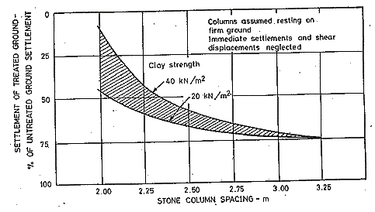  LOAD CAPACITY OF STONE COLUMNS  - The stone columns are assumed to carry the entire load with no contribution from the intermediate ground or atleast 80 % of the load.
 | OR
8 (a) | Give the classification of grouting methods of soils. Describe it in brief.  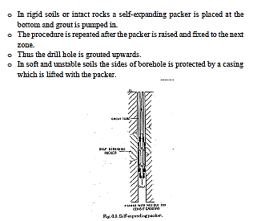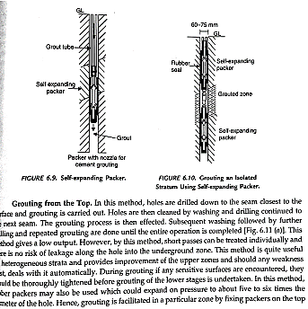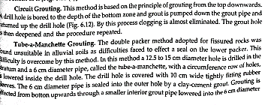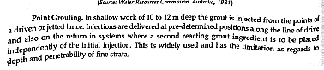 |  |  |  |  |  |  |  |  | [08]
8 (b) | What are the applications of grouting? Explain them briefly.  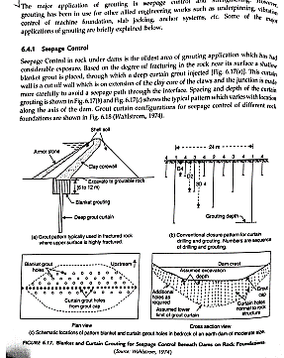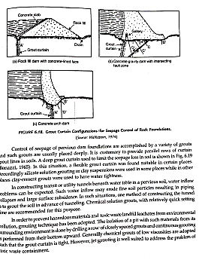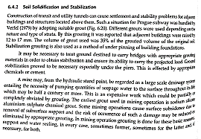 |  |  |  |  |  |  |  |  | [08]
 | Module 5
9 (a) | List the properties of geosynthetics. Explain any two.  - Compresibility  - Compressibility is the variation in thickness of the geosynthetic at different normal pressure.  - Thickness of woven geotextile is fairly constant with different normal pressures.  - Thickness of non-woven geotextile (especially needle punched) exhibit marked reduction in thickness with normal pressures.  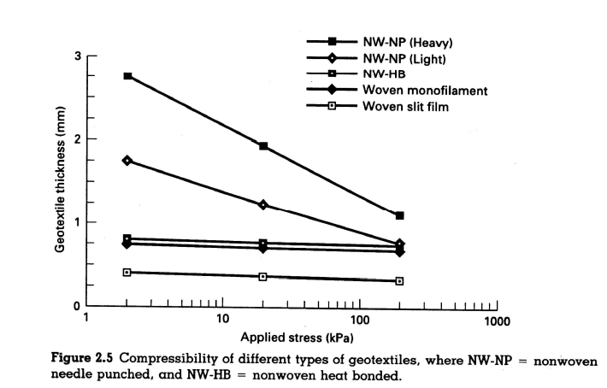  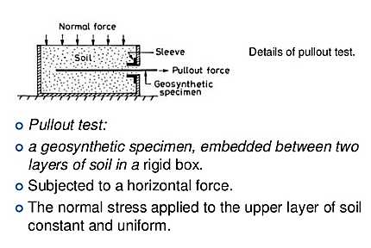  HYDRAULIC PROPERTIES  - In places where geosynthetics are used as a filter the geosynthetic should be sufficiently water permeable to not allow the pore pressure build up.  - As seen in bank protection works or bed protection works in canals.  - In certain places geosynthetics are used for land drainage. Here the geosynthetic should be permeable as well as soil tight.  - In order to satisfy both filtration and drainage requirements the geosynthetics need to fulfill two important conditions.  - It should have adequate hydraulic conductivity so that water is taken out of the soil in to the drain.  - It should not allow soil to be eroded away.  - This imply that the geosynthetic should have required opening size as well as a tight fabric structure.  - The hydraulic properties of a geosynthetic is governed by  - Fabric opening characteristics  - Water permeability  - Clogging resistance  - Fabric opening characteristics include the following  - The apparent opening size – the ability of a fabric to conduct water through it is dependent on the apparent opening size. It is the measure of the largest effective opening in the geosynthetic.  - Opening size distribution  - Percent open area – the ratio of total open area in a given fabric to the total area of the fabric  - Porosity – the ratio of volume of voids to the total volume. It is related to the ability of water to flow through the fabric.  - The permeability of the fabric must be greater than that of the protected soil. A good permeability ensures that partial clogging doesn’t reduce the permeability of the soil.  - Permeability is expressed in the following ways:  - Permittivity – it refers to the cross plane permittivity of the geosynthetic. It is equal to the cross plane permeability divided by the thickness of the geosynthetic. Unit is s-1. It is of significance in filtration.  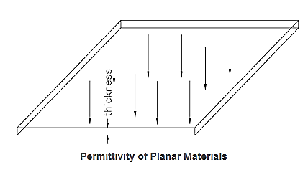  - Transmissivity – it is the flow rate per unit width per unit gradient. Unit is m2/s. It is of significance in drainage.  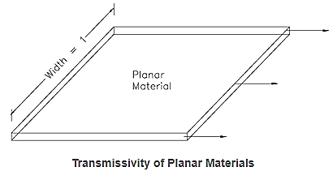  - Clogging is the movement of soil in to the fabric voids and retention of them in the fabric. Clogging reduces the flow rate through the fabric. |  |  |  |  |  |  |  |  | [08]
9 (b) | Explain the four most basic applications of geosynthetics.  APPLICATIONS OF GEOSYNTHETICS  SEPARATION  - Prevents the inter-mixing of particles between two layers of different properties.  - This prevents the contamination which may impair the intended behavior of granular soil layers.  - Geosynthetic as a separator is used in the following ways:  UNPAVED ROADS  Geosynthetic is used in unpaved roads primarily as a separator and secondarily for reinforcement and filtration. Providing a geosynthetic sheet between a granular sub-base and a weak subgrade helps to stabilize an unpaved road in a number of ways as follows –  - Provides local reinforcement  - Restrains the aggregate from downward and lateral movement in the ruts.  - Acts as a support membrane.  - Provides sufficient friction to limit lateral sliding of aggregate.  - Most of the actions explained above belong to reinforcement category, showing the essential nature of the secondary role.  - In the absence of geosynthetic the aggregate layer will get mixed up with the soft subgrade which would rapidly reduce its strength.  - Hence geosynthetic when used as a separator reduces the maintenance, enable better compaction during construction and reduce aggregate thickness layer.  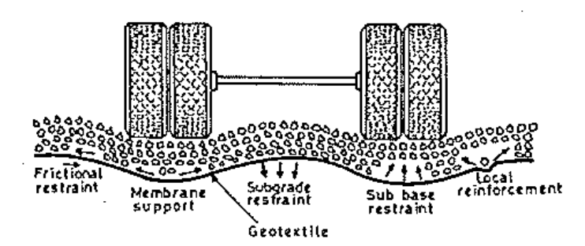  PAVED ROADS –  Rutting type of deflections of the surface is unacceptable in the case of paved roads. In this case geosynthetic can be provided at different location as stated below-  - At the interface between the aggregate sub-base and subgrade soil.  - Within the base course  - Below an overlay  In the first case geosynthetic acts in the exact same way as in an unpaved road. It has the following benefits –  - Prevents the pavement sub-base aggregate from penetrating the subgrade soil.  - Prevents fine soil particles from the subgrade soil entering the sub-base aggregate.  - Reduces the need for excavation of soft fine subgrade soils.  - Speeds placement of the sub-base aggregate during construction.  - Reduces rutting of the sub-base aggregate while it is being used as a haul road.  - Evens out settlement of the sub-base aggregate over any pockets of soft material.  - In the second application a geosynthetic of high elastic stiffness is used to bring some reinforcing effect.  - The presence of the geosynthetics will improve the tensile strength and gives the road greater resistance to cracking and helps to provide a longer fatigue life.  - The most effective location is for the geosynthetic is within the base course or between the base course and the wearing course at a depth not less than 40 mm.  - In the third application the geosynthetic is placed before laying the overlay. Here geosynthetic restricts the propagation of reflection cracks and thereby increases the life of the overlay.  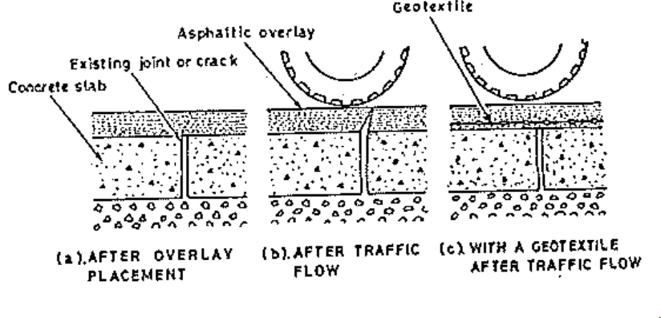  RAILWAYS  - When ballast rest on a poor soil then geosynthetic is used as a separator between the ballast and the clay. This separator function is always combined with drainage.  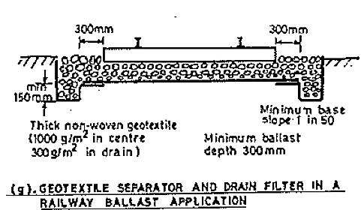  PROTECTION OF GEOMEMBRANES  - Geomembranes are used in containment systems as a barrier to leachates or even as tunnel lining as water proof membrane.  - Geomembranes have to resist tensile forces, puncture, and wear from objects.  - Geotextiles (thick non-woven geotextiles) are used to protect geomembranes which a separating function.  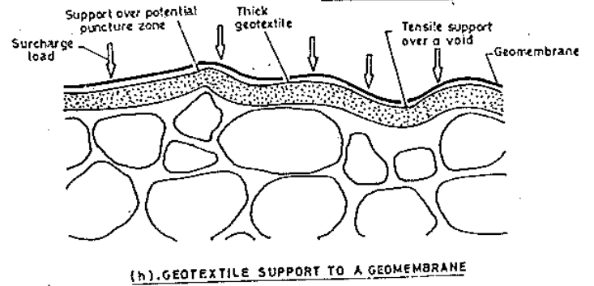  FILTRATION  - Geosynthetic filtration happens when only water is allowed to go and the soil is not allowed to go.  - Geotextiles must remain more permeable than the surrounding soil. (for critical applications permeability > 10 times the permeability of soil).  - As the flow of water happens through the soil-geotextile filter system the soil particles get deposited on the geotextile forming structures such as a bridge network or blinding (caking) and get entrapped inside the geotextile blocking the pores (phenomenon is referred as clogging).  - Cake formation and clogging depend on the type, thickness, size of pore and pore distribution of geotextile, fine content and density of the soil, hydraulic gradient etc.  - The geosynthetic for filter operation should be designed to prevent the following –  - Blocking  - The slope of the second part of the curve mf when it becomes zero then the discharge rate is constant. If mf reduces then the drainage rate reduces and may ultimately become completely cut off.  - Trench drains under highway and rail road are wrapped with geotextiles to prevent the entry of fines in to the drain.  Wrapping of trench drains  - Geosynthetics are used as a liner for sand blankets to prevent clogging of the sand blanket used for drainage.  Geosynthetic in retaining walls which acts like a filter  - Geotextiles are used as a filter jacket around the plastic core in prefabricated vertical drains.  In PVD  - Geoysnthetics are used to cover perforated drain pipes to prevent the entry of fines in to the pipes.  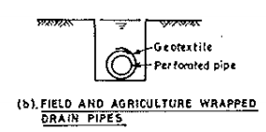  Covering perforated pipes  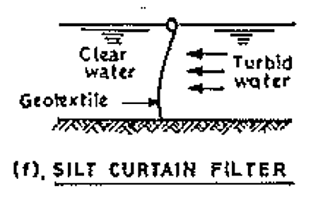  FLUID TRANSMISSION  - Geosynthetic drainage occurs either cross plane or in plane, when water is transmitted within the geosynthetic structure itself.  - A geosynthetic is used under the rail roads when the ballast is upon a clayey soil to prevent pumping.  - Pumping is the heaving of soil when it is loaded and not allowed to drain.  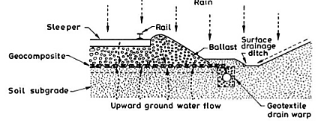  Drainage function under rail to prevent pumping  - Geosynthetic is used under pavements to drain off excess water.  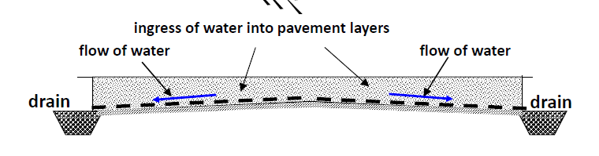  - Geosynthetics are also used to cut off capillary rise and drain off the capillary water.  - Geosynthetics are used for the lateral transmission of gases and leachate to prevent buildup near geomembranes in landfills.  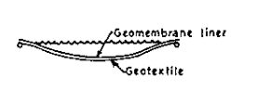  - Geosynthetics are used for horizontal and vertical drainage in soils which causes consolidation.  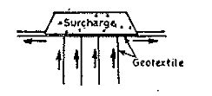  - Geosynthetics are used to drain the soil behind a retaining wall.  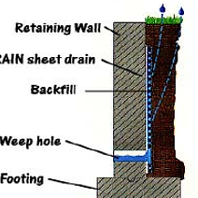  GEOSYNTHETIC AS A REINFORCEMENT  - Any strain or deformation could be controlled by introducing geosynthetics.  - As they provide frictional forces which resists the deformation.  - The three main areas where geosynthetics can be used are  - Foundations  - Slopes and embankments  - Retaining walls  - Polymers used for reinforcement are made of polyester, polyamide, polyethylene or polypropylene.  - They may have high UV degradation and corrosion resistance.  - The strain behavior of these polymers are time dependent , that is creep is significant.  - The design should include the maximum strength the geosynthetic should have and its relation with time.  UNDER FOOTINGS  - Geosynthetics are used as layers under the footing reinforcing the soil below the footing.  - The geosynthetics are embedded horizontally in the form of geocells, geogrids or geotextiles.  - This increases the bearing capacity beneath the footing and there is no need for opting for a raft foundation or for a combined footing.  UNDER EMBANKMENTS  - The types of failure modes for embankment made on soft soil are:  - Internal stability  - External stability  - Overall stability  - Foundation stability  - Bearing capacity failure  - The slope of the embankment is chosen such that the internal stability of the embankment is assured assuming that the subsoil has adequate bearing capacity. In case of inadequacy the embankment is laid in layers. Or the subsoil can be improved using a suitable ground improvement technique before laying the embankment. |  |  |  |  |  |  |  |  | [08]
 | OR
10 | Write short notes on the following:  - Soil nailing  Insitu soil reinforcement  In the insitu reinforcement technique the reinforcement is placed in an undisturbed soil to form a reinforced soil structure. This includes the technique of soil nailing and soil dowelling. The reinforcement used for insitu structures is usually linear owing to the method of installation.  Vertical or steeply inclined cuts can be made for open excavation using rigid soil nails as reinforcements. Such cuts are also referred to as nailed soil walls. Unlike reinforced soil walls which are constructed from bottom to top, nailed soil walls are constructed from top to bottom. The facing of such walls is usually in the form of a wire-mesh reinforced shot Crete panels, although metal plates and other types of panels have also been used. Soil nails are installed at an inclination of 20 to 25 degrees to the horizontal near the ground surface so as to avoid intercepting underground utilities and the inclination is reduced to 10 to 15 degrees as we go deeper into the cut.  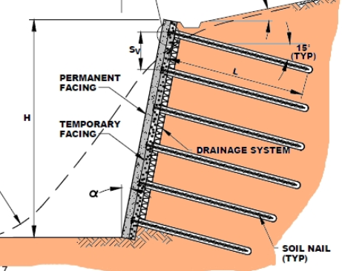  Steps for constructing soil nail reinforced slope  - Excavation  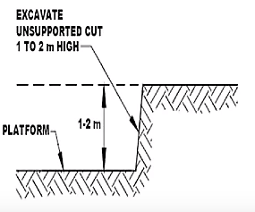  - DRILLING NAIL HOLES  Holes of diameter 100 mm to 300 mm is drilled at horizontal spacing of 1 m to 2 m.  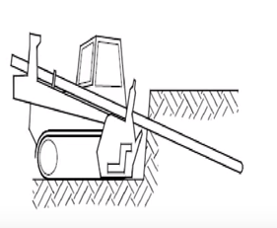  - NAIL INSTALLATION AND GROUTING  Nails are inserted in pre-drilled holes. Holes are filled with clean grout.  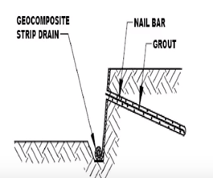  - Temporary wall facing  Shotcrete (75 mm thick) is applied to protect the excavated face and fill the voids and cracks on the slope.  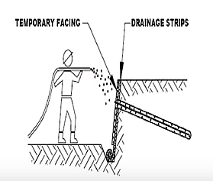  - Permanent wall facing  Shotcrete 150 mm to 300 mm is applied in layers.  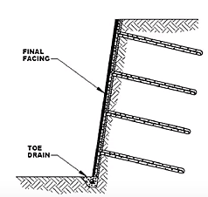  - Gabions and mattresses  GABION WALLS  - It is basically a rectangular wire mesh filled with stones.  - Size of the stones is always greater than the mesh.  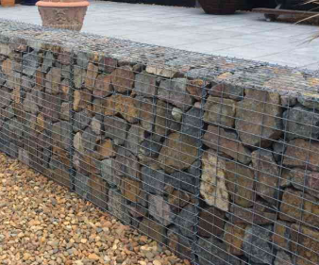  - The boxes are made of galvenized wire.  - Gabions are used in  - retaining structures.    - Revetment (revetment walls are constructed to protect the base of a slope from undermining or other damage) and toe walls to embankments and cuttings,  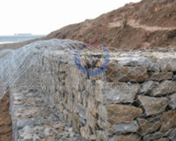  - anti-corrosion structures, such as sea walls, river bank defences, canal banks, dams, weirs, groynes and for the protection of reservoirs and lakesides.  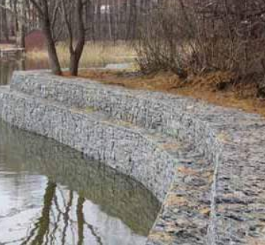  - The principal features of a gabion structure may be cited as durability,flexibility and permeability.  - As regards durability, over a period of time when the mesh starts to corrode, silt and vegetation will combine with the rock filling, forming a permanent structure which can stay intact even when the mesh has fully disappeared.  - Mention has already been made of gabion’s intrinsic feature of flexibility which enables it to adapt itself to any in-situ soil profile.  - What sets gabion apart from dry stone walling is that, the wire mesh being extremely strong in tension, the gabion structure can withstand a degree of tension which is quite impossible with dry stone walling.  - In this respect it must be emphasised that the wire mesh shell is not merely a frame to contain the stones; it serves as a reinforcement for the entire structure.  - Advantages of gabion The high permeability of gabion fill ensures automatic drainage, which obviates the need for measures such as the provision of weep holes. Besides everything else, gabions are considerably cheaper than their more conventional alternatives in terms of both material and labour.  - Soil reinforcement  To understand the mechanism by which reinforcement improves the performance of soil, let us look at two laboratory scale experiments. In the first case, a tank ABCD as shown in figure is filled with dry sand. When we remove side AB of the container, the vertical face of the sand does not remain stable and the soil mass rearranges itself as a sloping surface. We now repeat the same experiment by using geotextile material as reinforcement in soil mass. The geotextile is the flexible material that resembles a strong or thick sheet of cloth. This material is placed in horizontal layers when the sand is filled in the tank and it is folded at the ends as shown in figure. After removing the side AB, the vertical side does not collapse. We may observe some bulging but the face remains vertical and stable. This is so because, when the soil particles in the failure zone begin to collapse, the geotextile reinforcement prevents their movement  1. During the shearing stage, prior to failure, the reinforced soil sample shows lower radial and axial strain under the same deviator stress as compared to unreinforced sample.  2. At failure, the deviator stress of the reinforced sample is significantly larger than that of sample without reinforcement indicating higher shear strength of the former  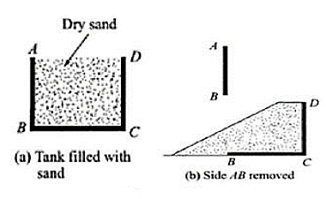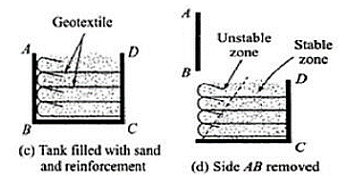  If we take two samples of medium-dense sand, one reinforced and the other not reinforced and test them in the triaxial apparatus under consolidated drained conditions. Two important observations can be made from these tests:  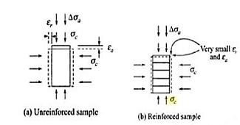  - Micro piles  Piles are divided in two general types as  a) Displacement piles  b) Replacement piles  Displacement piles are members that are driven or vibrated into the ground, there by displacing the surrounding soil laterally during installation. Replacement piles are placed or constructed with in a previously drilled borehole, thus replacing the excavated ground. A Micropile is a small diameter (< 300mm), drilled and grouted pile that is typically reinforced.  Micropiles are often used to underpin the existing structure where need of minimal vibration or noise is of prime importance.  • Micropiles can be easily laid where low head room is a constraint.  • Micropiles can be easily installed at any angle below the horizontal using the same equipment used for ground anchors and grouting projects.  • Offer a practical and cost-effective solution to costly alternative pile systems as well as a solution to job sites with difficult access.  • Do not require large access road or drilling platforms |  |  |  |  |  |  |  |  | [16]

