VTU June 2018 – Computer Integrated Manufacturing solution

1a) Automation is defined as “a technology concerned with the application of mechanical,electronics and computer based systems to operate and control production “.

(1) **Fixed Automation:-** It is the automation in which the sequence of processing or assembly operations to be carried out are fixed by the equipment configuration. In fixed automation, the sequences of operations (which are simple) are integrated in a piece of equipment. Therefore, it is difficult to automate changes in the design of the product. It is used where high volume of production is required Production rate of fixed automation is high. In this automation, no new products are processed for a given sequence of assembly operations. Features:- i) High volume of production rates, ii) Relatively inflexible in product variety (no new products are produced). Ex:- Automobile industries … etc.

(2) **Programmable Automation:-** It is the automation in which the equipment is designed to accommodate various product configurations in order to change the sequence of operations or assembly operations by means of control program. Different types of programs can be loaded into the equipment to produce products with new configurations (i.e., new products). It is employed for batch production of low and medium volumes. For each new batch of different configured product, a new control program corresponding to the new product is loaded into the equipment. This automation is relatively economic for small batches of the product. Features:- i) High investment in general purpose, ii) Lower production rates than fixed automation, iii) Flexibility & Changes in products configuration, iv) More suitable for batch production. Ex:- Industrial robot, NC machines tools… etc.

(3) **Flexible Automation:-** A computer integrated manufacturing system which is an extension of programmable automation is referred as flexible automation. It is developed to minimize the time loss between the changeover of the batch production from one product to another while reloading. The program to produce new products and changing the physical setup i.e., it produces different products with no loss of time. This automation is more flexible in interconnecting work stations with material handling and storage system. Features:- i) High investment for a custom engineering system. ii) Medium Production rates iii) Flexibility to deal with product design variation, iv) Continuous production of variable mixtures of products. Ex:- Flexible manufacturing systems (FMS)

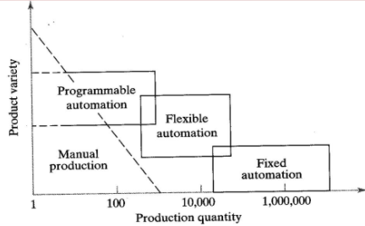

1 b) The need for automation are:

(i) To Increase the Productivity Rate of Labour

(ii) To Decrease the Cost of Labour

(iii) To Minimize the Effect of Shortage of Labour

(iv) To Obtain High Quality of Products

(v) A Non-automation nigh Cost is Avoided

(vi) To Decrease the Manufacturing Lead Time

(vii) To upgrade the Safety of Workers.

(viii) Reduction of in-process inventory.

(ix) To obtain product variety much easily.

(x) Can be implemented in regions where human activity isn’t feasible.

2a) **Upper-bound approach**  
The upper-bound approach provides an estimate of the upper limit on the frequency on line stops per cycle. We assume here that a breakdown at a station does not cause the part to be removed from that station. In this case it is possible, perhaps likely, that there will be more than one line stop associated with a particular work part. An example of this situation is that of a hydraulic failure at a workstation which prevents the feed mechanism from working. Another possibility is that the cutting tool has nearly worn out and needs to be changed. Or, the workpart is close to being out of tolerance and a tool adjustment is required to correct the condition. With each of these examples, there is no reason for the part to be removed from the transfer machine. Let pi represent the probability that a part will jam at a particular station i, where i   = 1, 2,    . .  .  , n. Since the parts are not removed when a station jam occurs, it is possible (although not probable) that the part will jam at every station. The expected number of line stops per part passing through the line can be obtained merely by summing up the probabilities p, over the n stations. Since each of the n stations is processing a part each cycle, this expected number of line stops per part passing through the line is equal to the frequency of line stops per cycle. Thus,  
[Formula5.9](https://rekadayaupaya.files.wordpress.com/2013/05/formula5-9.jpg)

If the probabilities p are all equal, p1 = p2   = . . . = pn  = p, then

[Formula5.10](https://rekadayaupaya.files.wordpress.com/2013/05/formula5-10.jpg)

**Lower-bound approach**  
The lower-bound approach gives an estimate of the lower limit on the expected number of line stops per cycle. In this approach we assume that the station breakdown results in the destruction or damage of the workpiece. For example, a drill or tap breaks off in the part during processing. The broken tool must be replaced at the workstation and the work part must be removed from the line for subsequent rework or scrap. Accordingly, the part cannot proceed to the next stations for further processing.

3a)

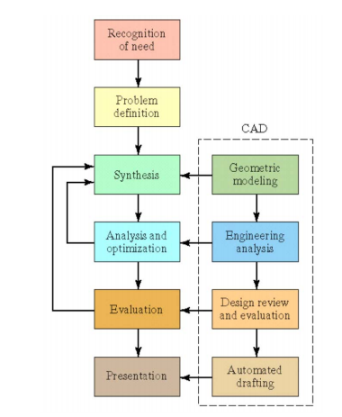

**Recognition of need**—this involves the realisation that a problem or need exists that may be solved by design. This may mean identifying some deficiency in a current machine design by an engineer, or perceiving some new product opportunity by a salesperson. Problem definition—this involves a thorough specification of the item to be designed. Specifications include physical characteristics, function, cost, quality, and operating performance.

**Synthesis**—closely related with the following step, analysis, synthesis refers to the bundling of information that occurs after problem definition, and concurrently during analysis, and after re-analysis.

**Analysis and optimization**—closely related to the previous step, analysis is concerned with the investigation of design specification information, and the optimization of this information, as well as a synthesis of new information, as required.

**Evaluation**—involves measuring the design against the specifications established in the problem definition phase. This evaluation may require the building and testing of prototype models to assess operative performance metrics for the proposed design. This may lead to the re-design of certain or all elements.

**Presentation**—this is the final phase, where the design is documented by means of drawings, material specifications, assembly lists, and so on. Documentation means that the design database is created. ENDLIST

3b:

1. Generation of graphic elements
2. Transformations
3. Display control and windowing functions
4. Segmenting
5. User input functions

a)A graphic package element in a computer is the basic image entity such as dor,line, circle etc.They include alphanumeric characters, special symbols etc. They are used as primitive blocks to construct 3D models.

b) used to change or reposition the graphical entities in the database. Tansformations include enlargement or reduction of entity.

c) These functions help the user to view the image from desired angles and at the desired magnification. This functions are sometimes referred as windowing functions.

d)These have the capability to selectively replace delete or modify the portions of the image. Executive functions cannot be used in storage to as there will be no selective the erase.

e)These are the functions which help the user to enter commands the input functions must be written for specific input devices these input functions are defined in such a way that even the user without any programming experience can also work effectively.

4a)

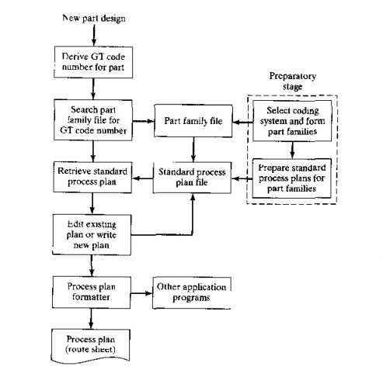

A *retrieval CAPP* system, also called a *variant CAPP* system, is based on the principles of group technology (GT) and parts classification and coding. In this type of CAPP, a standard process plan (route sheet) is stored in computer files for each part code number. Before the system can be used for process planning, a significant amount of information must be compiled and entered into the CAPP data files. This is the "preparatory phase:' It consists of the following steps:

(1) selecting an appropriate classification and coding scheme for the company,

(2) forming part families for the parts produced hy the company; and

(3) preparing standard process plans for the part families. It should be mentioned that steps (2) and (3) continue as new parts are designed and added to the company's design data base.

After the preparatory phase has been completed, the system is ready for use, For a new component for which the process plan is to be determined. the first step is to derive the GT code number for the part. With this code number, a search is made of the part family, *file* to determine if a standard route sheet exists for/he given part code. If the file contains a process plan for the part it is retrieved and displayed for the user. The standard process plan is examined to determine whether any modifications are necessary. It might be that although the new part has the same code number. there are minor differences in the processes required to make it. The user edits the standard plan accordingly. This capacity to alter an existing process plan is what gives the retrieval system its alternative name: variant CAPP system.

 If the file does not contain a standard process plan for the given code number, the user may search the computer file for a similar or related code number for which a standard route sheer does exist. Either by editing an existing process plan, or by starting from scratch, the user prepares the route sheet for the new part. This route sheet becomes the standard process plan for the new part code number

 The process planning session concludes with the process plan formatter, which prints alit the route sheet in the proper format. The formatter may call other application programs into use: for example, to determine machining conditions for the various machine tool operations in the sequence. to calculate standard times (or the operations (e.g., for direct labor incentives). or to compute cost estimates for the operations.

4b)

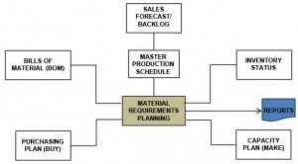

MRP has several objectives, such as:

* **Reduction in Inventory Cost**: By providing the right quantity of material at right time to meet master production schedule, MRP tries to avoid the cost of excessive inventory.
* **Meeting Delivery Schedule**: By minimizing the delays in materials procurement, production decision making, MRP helps avoid delays in production thereby meeting delivery schedules more consistently.
* **Improved Performance**: By stream lining the production operations and minimizing the unplanned interruptions, MRP focuses on having all components available at right place in right quantity at right time.

**MRP System**

A simple sketch of an MRP system is shown. It can be seen from the figure that an MRP system has three major input components:

* **Master Production Schedule (MPS**): MPS is designed to meet the market demand (both the firm orders and forecasted demand) in future in the taken planning horizon. MPS mainly depicts the detailed delivery schedule of the end products. However, orders for replacement components can also be included in it to make it more comprehensive.
* **Bill of Materials (BOM) File**: BOM represents the product structure. It encompasses information about all sub components needed, their quantity, and their sequence of buildup in the end product. Information about the work centers performing buildup operations is also included in it.
* **Inventory Status File**: Inventory status file keeps an up-to-date record of each item in the inventory. Information such as, item identification number, quantity on hand, safety stock level, quantity already allocated and the procurement lead time of each item is recorded in this file.

After getting input from these sources, MRP logic processes the available information and gives information about the following:

* **Planned Orders Receipts**: This is the order quantity of an item that is planned to be ordered so that it is received at the beginning of the period under consideration to meet the net requirements of that period. This order has not yet been placed and will be placed in future.
* **Planned Order Release**: This is the order quantity of an item that is planned to be ordered in the planned time period for this order that will ensure that the item is received when needed. Planned order release is determined by offsetting the planned order receipt by procurement lead time of that item.
* **Order Rescheduling**: This highlight the need of any expediting, de-expediting, and cancellation of open orders etc. in case of unexpected situations.

5a)

The different types of flexibility that are exhibited by manufacturing systems are given:

a). Machine Flexibility. It is the capability to adapt a given machine in the system to a wide range of production operations and part styles. The greater the range of operations and part styles the greater will be the machine flexibility. The various factors on which machine flexibility depends are:

* Setup or changeover time
* Ease with which part-programs can be downloaded to machines
* Tool storage capacity of machines
* Skill and versatility of workers in the systems

b). Production Flexibility. It is the range of part styles that can be produced on the systems. The range of part styles that can be produced by a manufacturing system at moderate cost and time is determined by the process envelope. It depends on following factors:

* Machine flexibility of individual stations
* Range of machine flexibilities of all stations in the system

c). Mix Flexibility. It is defined as the ability to change the product mix while maintaining the same total production quantity that is, producing the same parts only in different proportions. It is also known as process flexibility. Mix flexibility provides protection against market variability by accommodating changes in product mix due to the use of shared resources. However, high mix variations may result in requirements for a greater number of tools, fixtures, and other resources. Mixed flexibility depends on factors such as:

* Similarity of parts in the mix
* Machine flexibility
* Relative work content times of parts produced

d). Product Flexibility. It refers to ability to change over to a new set of products economically and quickly in response to the changing market requirements. The change over time includes the time for designing, planning, tooling, and fixturing of new products introduced in the manufacturing line-up. It depends upon following factors:

* Relatedness of new part design with the existing part family
* Off-line part program preparation
* Machine flexibility

e). Routing Flexibility. It can define as capacity to produce parts on alternative workstation in case of equipment breakdowns, tool failure, and other interruptions at any particular station. It helps in increasing throughput, in the presence of external changes such as product mix, engineering changes, or new product introductions. Following are the factors which decides routing flexibility:

* Similarity of parts in the mix
* Similarity of workstations
* Common tooling

f). Volume Flexibility. It is the ability of the system to vary the production volumes of different products to accommodate changes in demand while remaining profitable. It can also be termed as capacity flexibility. Factors affecting the volume flexibility are:

* Level of manual labor performing production
* Amount invested in capital equipment

g). Expansion Flexibility. It is defined as the ease with which the system can be expanded to foster total production volume. Expansion flexibility depends on following factors:

* Cost incurred in adding new workstations and trained workers
* Easiness in expansion of layout
* Type of part handling system used

5b)

An AS/RS consists of one or more storage aisles that are serviced by a storage/retrieval (S/R) machine. The stored materials are held by storage racks of aisles. The S/R machines are used to deliver and retrieve materials in and out of inventory. There are one or more input/output stations in each AS/RS aisle for delivering the material into the storage system or moving it out of the system. In AS/RS terminology, the input/output stations are called pickup-and-deposit (P&D) stations.

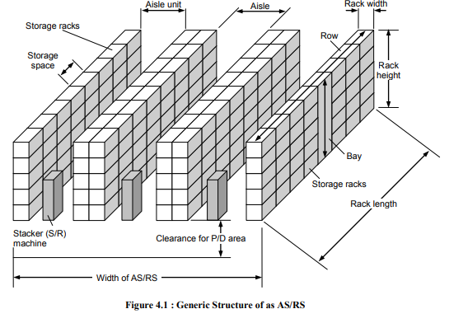

Storage Space It is the three-dimensional space in the storage racks used to store a single load unit of material.

Storage Racks This structural entity comprises storage locations, bays and rows.

Bay It is the height of the storage rack from floor to the ceiling. Row It is a series of bays placed side by side.

Aisle It is the spacing between two rows for the machine operations of AS/RS. Aisle Unit It encompasses aisle space and racks adjacent to an aisle.

Storage Structure It is the rack framework, made of fabricated steel that supports the loads contained in the AS/RS and is used to store inventory items.

Storage/Retrieval Machine It is used to move items in and out of inventory. An S/R machine is capable of both horizontal and vertical movement.

A rail system along the floor guides the machine and a parallel rail at the top of the storage structure is used to maintain its alignment.

Storage Modules These are the unit load containers used to hold the inventory items. These include pallets, steel wire baskets and containers, pans and special drawers. These modules are generally made to a standard base size capable of being stored in the structure and moved by the S/R machines.

Pickup and Deposit (P/D) Stations P/D stations are where inventory are transferred into and out of the AS/RS. They are generally located at the end of the aisles to facilitate easy access by the S/R machines from the external material-handling system. The location and number of P/D stations depends upon the origination point of incoming loads and the destination of output loads.

6a)

* 1. The minimum rational work elements are the smallest practical indivisible tasks into which the job can be divided. These work elements cannot be subdivided further. For example, the drilling of a hole would normally be considered as a minimum rational work element.
  2. Cycle Time (CT) Cycle Time may be defined as the ratio between the effective time avai!able per period and the production volume per period. Effective time available = (Time per period) X per period (%Utilization of period) The cjcle time may also be interpreted in the following ways: o It is the time between consecutive releases of finished assemblies from the last station of the line. It is the time between consecutive releases of semi - finished products between any two adjacent stations. It is the maximum time allocated per station.
  3. Precedence constraints are also called as technical sequence requirements which restricts the sequence of operations.
  4. Precedence diagram consists of what elements which are shown as per their sequence relations.

7a)

When classified according to the machine tool control system,there are three basic types of NC systems :   
1. Point to Point.   
2. Straight cut.   
3. Contouring.

The classification is concerned with the amount of control over the relative motion between the workpiece and cutting tool . The least control is exerted over the tool motion with the point to point systems.  Contouring  represents the highest level of control.

**Point-to-Point NC**   
*Point to point* is also sometimes called a positioning system. In PTP the objective of themachine tool control system is to move the cutting tool to predefined location.  The speedor path by which this movement is accomplished is not important in point to point NC.  Once the tool reaches the desired location, the machining operation is performed at that position.  NC drill presses are a good example of PTP systems.  The spindle must first be positioned at a particular location n the workpiece. This is done under PTP control . Then the drilling of the holes is performed at that location,the tool is  moved to the next hole location, and so forth.  Since no cutting is performed between holes there is no need for controlling the relative motion of the tool and workpiece betwwen hole locations.  On positioning systems the speeds and feeds used by the machine tool are often used by the machine operater rather than by the nc tape. Positioning systems are the simplest machine tool control systems and  therefore the least expensive of the three types. However for certain processes such  as drilling operations and spot welding.  PTP is perfectly suited to task and any higher level of control is unnecessary.

**Straight Cut NC**   
*Straight cut* control systems are capable of moving the cutting tool parallel to one of the major axes at a controlled rate suitable for machining . It is therefore appropriate for performing milling operations to fabricate workpieces of rectangular configuartions. With this type of NC systems it is therefor appropriate for performing milling operations to fabricate workpieces of rectangular configuartions . With this type of NC system it is not possible to combine movements in more than single axis direction. Therefore angular cuts on the workpiece would not be possible. An NC machine tool capable of performing straight cut movements is also capable of point to point movements.

**Contouring NC**   
*Contouring* is the most complex flexible and teh most expensive type of machine tool control . It is capable of performing both PTP and straight cut opeartions . In addition th edistinguishning feature of the of contouring NC system is their capacity for simultaneousl control of more than one axis movement of machine tool Figures below illustrate the versatility of continuous path NC. Milling and Turning are the common examples of  the use of conturing control.

7b)

8a) 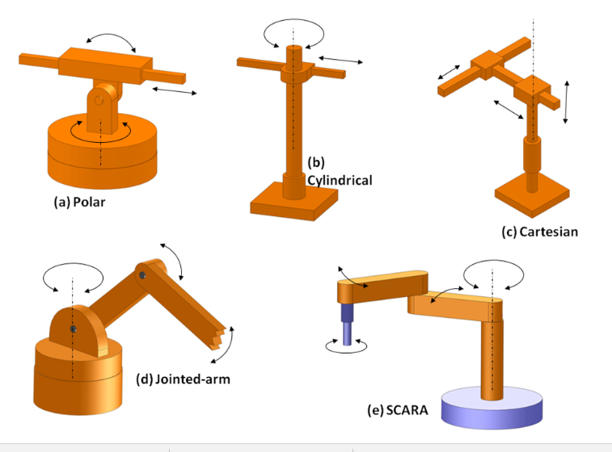

**a.** **Polar configuration**

It consists of a sliding arm L-joint, actuated relative to the body, which rotates around both a vertical axis (T-joint), and horizontal axis (R-joint).

**b.**  **Cylindrical configuration**

It consists of a vertical column. An arm assembly is moved up or down relative to the vertical column. The arm can be moved in and out relative to the axis of the column. Common configuration is to use a T-joint to rotate the column about its axis. An L-joint is used to move the arm assembly vertically along the column, while an O-joint is used to achieve radial movement of the arm.

**c.**  **Cartesian co-ordinate robot**

It is also known as rectilinear robot and x-y-z robot. It consists of three sliding joints, two of which are orthogonal O-joints.

**d.**  **Jointed-arm robot**

It is similar to the configuration of a human arm. It consists of a vertical column that swivels about the base using a T-joint. Shoulder joint (R-joint) is located at the top of the column. The output link is an elbow joint (another R joint).

**e.**  **SCARA**

Its full form is ‘Selective Compliance Assembly Robot Arm'. It is similar in construction to the jointer-arm robot, except the shoulder and elbow rotational axes are vertical. It means that the arm is very rigid in the vertical direction, but compliant in the horizontal direction.

Robot wrist assemblies consist of either two or three degrees-of-freedom. A typical three-degree-of-freedom wrist joint is depicted in Figure 7.5.4. The roll joint is accomplished by use of a T-joint. The pitch joint is achieved by recourse to an R-joint. And the yaw joint, a right-and-left motion, is gained by deploying a second R-joint.

8b)

i) This sensor allows the user to measure the difference between the velocity of the **Roller** and **assembly (web)**. The beam element is that passes between the center position of the **Sensor** and **Roller**.

£ The direction of the sensor is the tangential direction of the center position of the sensor and the center position of the **Roller**.

£ The position of the element center of a sensing belt is to be a sensing point.

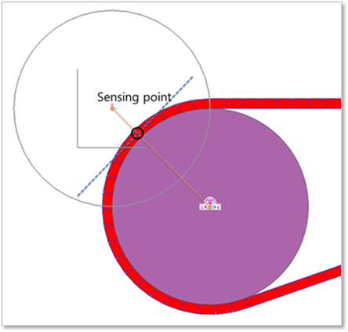

Figure 1  Sensing point of the beam element.

The sensor output can be computed from the following equation.

•**Vp** = [the rotational velocity of roller] * [the distance between the center of roller and the center line of the beam assembly]

•**Vb** = [the velocity of the center line of the beam assembly for the tangential direction of the radius of roller]

•**Result_Slip_Sensor =**(**Vb**-**Vp**)

# ii) Range Sensor

The Modern Robotics Range Sensor measures distances from 1cm to 255cm. The Range Sensor combines an ultrasonic sensor to detect objects from approximately 5cm to 255 cm and an optical sensor to detect objects closer than 5cm.

iii) with increased automation of complex production systems, components that are capable of acquiring and transmitting information regarding the production process become necessary. Proximity sensors -- the most basic data acquisition devices in automation -- fulfill these requirements by providing information in the form of individual process variables to controllers. They measure such variables as force, length, temperature and pressure and detect proximity of an object without any physical contact. They come in many types, each with its unique advantages.

9a)

**Step 1 – 3D model creation**

First a 3D model of the object is created using CAD software or a 3D object scanner

**Step 2 – STL file creation**

CAD model is converted to a STL file to tessellate the 3D shape and slice it into digital layers

**Step 3 – STL file transfer**

STL file is then transferred to the printer using custom machine software

**Step 4 – Machine set up**

Consumables are then loaded and the printer is set-up with printing parameters

**Step 5 – Build**

Printer builds the model by depositing material layer by layer

**Step 6 – Part Removal**

Part is then removed from the build platform and its support structure

**Step 7 – Post processing**

Finally, post processing, such as cleaning, polishing, and painting might be required

9b)

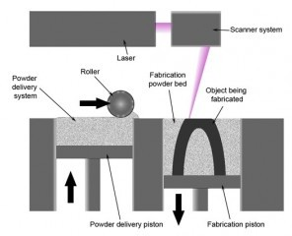

* The **Selective Laser Sintering process**begins with the conversion of customer generated 3D CAD data into a sliced STL file using proprietary software. Once created the STL file is then sent to print on the Selective Laser Sintering machine.

* The machine warms up (with LS material heated to just below melting point) prior to the feed bed rises (typically by <0.1mm) and the levelling roller pushes fresh powder across the build platform/part bed.

* The first layer is then traced out by a CO2 laser which melts and fuses the LS material upon contact. Once the first layer has completed the build platform/part bed drops by a pre-set amount.

* The feeder bed rises and a fresh layer of powder is swept along the build platform. The next layer is then traced out and the process repeats layer by layer until the model has “fully grown”.

* Upon completion the model is left to cool before being removed and any loose material brushed away (as the **Selective Laser Sintering process** requires no support structures)

10a)

The components of industry 4.0 are:

1. System Integration

Many systems are highly automated within their own operation, but struggle to commu­nicate with other systems. Standards and open architecture support the easy transfer of information, both to the business and the customer and/or end user. This can involve defining common languages for data exchange such as JDF for job information, CxF for color information, and PDF for content.

1. Big Data and Analytics

As systems become increasingly digitized and connected, there is a great deal of data that can be collected and analyzed. One of the challenges is the quantity of data. Too much data makes it difficult to identify the relevant information and trends that can lead to intelligent and automated decisions. This is where “big” data and analytics come in. Big data and analytics make it possible to identify the performance of an individual component and its operating restrictions in order to prevent future production issues and take preventative action.

1. Simulation and Virtualization

The simulation and virtualization of systems allow for different scenarios to be assessed. Once systems are assessed, cost-effective solutions can be developed, tested, and implemented much faster, ultimately leading to reduced costs and time to market. An example of simulation would be color management and control, where in-line measurements can be used to minimize set up times and optimize subsequent press runs.

1. Internet of Things (IoT)

The IoT is a key functionality in Industry 4.0 driven solu­tions. The IoT combines physical devices via the network to collect data for the decision making process. This embedded computing enhances the value and functionality of the product being manufactured.

1. The Cloud

The Cloud is being used for applications such as remote service, color management, and performance benchmarking, and its role in other business areas will continue to expand. With continuous advancements in technology, machine data and functionality will only continue to be shifted towards Cloud solutions. The Cloud allows for a much faster roll out of updates, performance models, and delivery options than stand-alone systems. The industry has seen a large shift in utilizing Cloud solutions, and this will continue to grow.

1. Cybersecurity

As we move away from closed systems (with the increased connectivity from the IoT and Cloud), the security of information becomes paramount. Security and reliability enable the successful implementa­tion of a truly modern and digitized production workflow, leveraging all of the benefits of a connected environment.

1. Autonomous Robots

Although robotics is in its early stages in the graphic communi­cations industry, we have seen an increase in use through specific manufacturing systems; for example, activities such as materials movement (as in the Cox Target Media facility) and/or with product inventory control. We expect the level of performance and interaction with humans and systems to improve, and we anticipate increased use of robotics by leading print companies.

1. Augmented Reality

Augmented reality grows in use by providing real-time information in an effective manner to allow humans to better integrate and interact with electronic systems. Examples can include the transmission of information on repairs for a part that can be viewed through different devices or the training of personnel using simulations and 3D views of the facility or equipment.

10b)

### 1. Digital/connected factory:

IoT enabled machinery can transmit operational information to the partners like original equipment manufacturers and to field engineers. This will enable operation managers and factory heads to remotely manage the factory units and take advantage of process automation and optimization. Along with this, a digitally connected unit will establish a better line of commands and help identify key result areas (KRAs) for managers.

### 2. Facility management:

The use of IoT sensors in manufacturing equipment enables condition-based maintenance alerts. There are many critical machine tools that are designed to function within certain temperature and vibration ranges. IoT Sensors can actively monitor machines and send an alert when the equipment deviates from its prescribed parameters. By ensuring the prescribed working environment for machinery, manufacturers can conserve energy, reduce costs, eliminate machine downtime and increase operational efficiency.

### 3. Production flow monitoring:

IoT in manufacturing can enable the monitoring of production lines starting from the refining process down to the packaging of final products. This complete monitoring of the process in (near) real-time provides scope to recommend adjustments in operations for better management of operational cost. Moreover, the close monitoring highlights lags in production thus eliminating wastes and unnecessary work in progress inventory.

### 4. Inventory management:

IoT applications permit the monitoring of events across a supply chain. Using these systems, the inventory is tracked and traced globally on a line-item level and the users are notified of any significant deviations from the plans. This provides cross-channel visibility into inventories and managers are provided with realistic estimates of the available material, work in progress and estimated the arrival time of new materials. Ultimately this optimizes supply and reduces shared costs in the value chain.

### 5. Plant Safety and Security:

IoT combined big data analysis can improve the overall workers’ safety and security in the plant. By monitoring the Key Performance Indicators (KPIs) of health and safety, like the number of injuries and illness rates, near-misses, short- and long-term absences, vehicle incidents and property damage or loss during daily operations. Thus, effective monitoring ensures better safety. Lagging indicators, if any, can be addressed thus ensuring proper redressal health, safety, and environment (HSE) issues.

### 6. Quality control:

IoT sensors collect aggregate product data and other third-party syndicated data from various stages of a product cycle. This data relates to the composition of raw materials used, temperature and working environment, wastes, the impact of transportation etc. on the final products. Moreover, if used in the final product, the IoT device can provide data about the customer sentiments on using the product. All of these inputs can later be analyzed to identify and correct quality issues.

### 7. Packaging Optimization:

By using IoT sensors in products and/or packaging, manufacturers can gain insights into the usage patterns and handling of product from multiple customers. Smart tracking mechanisms can also trace product deterioration during transit and impact of weather, road and other environment variables on the product. This will offer insights that can be used to re-engineer products and packaging for better performance in both customer experience and cost of packaging.

### 8. Logistics and Supply Chain Optimization:

The Industrial IoT (IIoT) can provide access to real-time supply chain information by tracking materials, equipment, and products as they move through the supply chain. Effective reporting enables manufacturers to collect and feed delivery information into ERP, PLM and other systems. By connecting plants to suppliers, all the parties concerned with the supply chain can trace interdependencies, material flow and manufacturing cycle times. This data will help manufacturers predict issues, reduces inventory and potentially reduces capital requirements.

8b) 