CMR  INSTITUTE OF  TECHNOLOGY |  |  |  |  |  |  |  |  |  | 
 |  |  | USN 1 C R
Internal Assesment Test – 2
Sub: Control Engineering |  |  |  |  |  |  |  | Code: 10ME82
Date: 19/04/2018 |  | Duration: 90 mins |  | Max Marks: 50 | Sem: 8 | Branch (sections): ME (A,B)
Answer any ONE question from Part A and TWO questions from Part B. Good luck!
PART A |  |  |  |  |  |  | Marks |  | OBE
 |  |  |  |  |  |  |  |  | CO |  | RBT
1 | Obtain the overall transfer function of the block diagram by reduction technique.  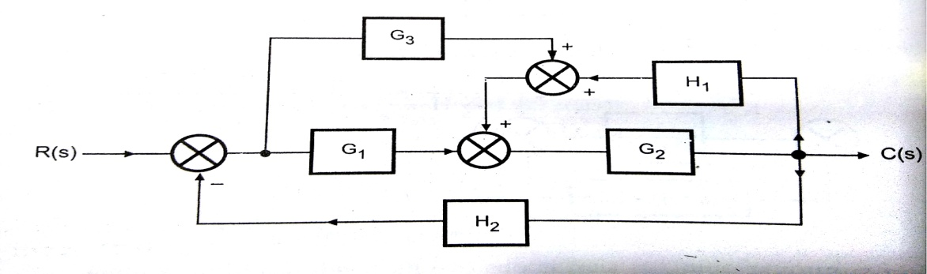 |  |  |  |  |  | [10] |  | CO2 |  | L3
2 | Obtain the overall transfer function by using Mason’s gain formula. |  |  |  |  |  | [10] |  | CO2 |  | L3
 | 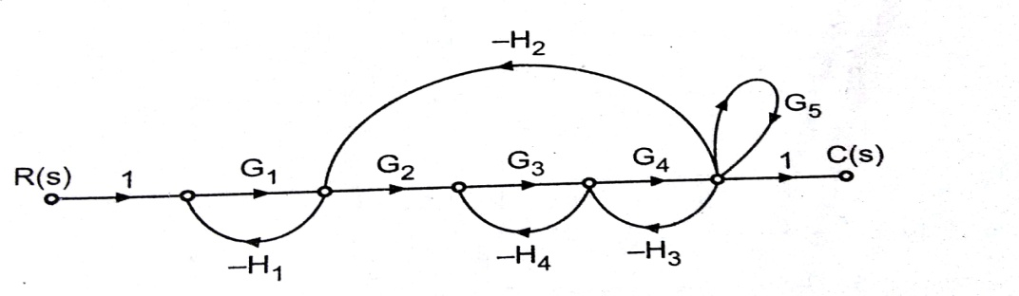

CMR
INSTITUTE OF
TECHNOLOGY
 |  |  | USN 1 C R
Internal Assesment Test – 2
Sub: Control Engineering |  |  |  |  |  |  |  | Code: 10ME82
Date: 19/04/2018 |  | Duration: 90 mins |  | Max Marks: 50 | Sem: 8 | Branch (sections): ME (A,B)
Answer any ONE question from Part A and TWO questions from Part B. Good luck!
PART A |  |  |  |  |  |  | Marks |  | OBE
 |  |  |  |  |  |  |  |  | CO |  | RBT
1 | Obtain the overall transfer function of the block diagram shown in fig. 1 by reduction technique. |  |  |  |  |  | [10] |  | CO2 |  | L3
2 | Obtain the overall transfer function by using Mason’s gain formula. |  |  |  |  |  | [10] |  | CO2 |  | L3

3 | PART B  The open loop transfer function of a unity feedback system is $G\left(s\right)=\frac{K(s+2)}{s(s+4)(s+10)}$  Find K to get PM = +30° | [20] | CO6 | L4
4 | Sketch the Bode plot for the transfer function$G\left(s\right)H\left(s\right)=\frac{{Ks}^{2}}{\left(1+0.02s\right)(1+0.2s)}$  Determine the value of K for the gain cross over frequency to be 5 rad/sec. | [20] | CO6 | L4
5 | For a certain feedback system $G\left(s\right)H\left(s\right)=\frac{3\left(s+1\right)(s+6)}{s^{2}(s^{2}+18s+400)}$ .  Sketch the Bode plot and comment on G.M, P.M and stability. | [20] | CO6 | L4

3 | PART B  The open loop transfer function of a unity feedback system is $G\left(s\right)=\frac{K(s+2)}{s(s+4)(s+10)}$  Find K to get PM = +30° | [20] | CO6 | L4
4 | Sketch the Bode plot for the transfer function$G\left(s\right)H\left(s\right)=\frac{{Ks}^{2}}{\left(1+0.02s\right)(1+0.2s)}$  Determine the value of K for the gain cross over frequency to be 5 rad/sec. | [20] | CO6 | L4
5 | For a certain feedback system $G\left(s\right)H\left(s\right)=\frac{3\left(s+1\right)(s+6)}{s^{2}(s^{2}+18s+400)}$ .  Sketch the Bode plot and comment on G.M, P.M and stability. | [20] | CO6 | L4

